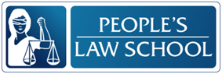
Learning about the Law Lesson: Family Law – Marriage, Separation and Divorce

CLB 5-6 Instructional Package

Lesson Plan: Marriage, Separation, and Divorce (CLB 5-6)
CLB Outcomes
CLB 5-IV: Sharing Information | Agree, disagree and give opinions in small group discussions or meetings.
CLB 5-IV: Comprehending Information | Understand simple to moderately complex descriptive or narrative texts on familiar topics.
CLB 5-II: Reproducing Information | Reduce a page of information to a list of important details.
Content Outcomes
- Identify basic definitions related to marriage, separation, and divorce
- Describe rules and practices related to marriage, separation, and divorce
- Give a comparison of Family Law in Canada and home countries

Resources
- People’s Law School (PLS) wikibook Learning about the Law, section on Learning About Family Law, or the PLS Learning About the Law (Family Law, Young People and the Law, Elder Law) booklet, section on Family Law.
- PLS worksheets “Family Law: Marriage, Separation, and Divorce”
- Computer Lab (optional)

External Resources and Referrals
- For more information on children’s rights in cases of separation and divorce, visit www.familylaw.lss.bc.ca
- Invite a family justice counsellor/ Legal Services Society officer to speak to the class about community services, and free family justice services available for the residents of British Columbia
- Visit a community or government agency providing support to families and children

Assessment Plan and Tools
- Self-assessment checklist

Sample Lesson Plan
Time | Sample Tasks | Expected Outcome | Resources
10’ | Warm up  - In small groups, students discuss the pictures and how they relate to family laws | Generate interest  Activate prior knowledge | PLS Worksheet:  Get Ready!
25’ | Vocabulary practice  - Hand out one definition to each student in the class  - First, students circle all of the words on the list that they already know and write their own definitions for those words  - Next, students look in the Learning about the Law wikibook (section on Learning About Family Law) or PLS Learning About the Law (Family Law, Young People and the Law, Elder Law) booklet (section on Family Law) to find the words they don’t know in order to try to understand them  - Finally, students circulate around the room to ask classmates about words they don’t know in order to find the correct definition  - Students record the definitions on their worksheet  - Check and go over any new words | Prepare for reading  Apply strategies to learn new vocabulary words related to the topic | PLS Worksheet: Vocabulary Practice!  Learning about the Law wikibook or PLS Learning About the Law (Family Law, Young People and the Law, Elder Law) booklet
15’ | - Pronunciation practice  - Students break words into syllables and mark stress  - Drill pronunciation with students | Pronounce words with correct word stress | PLS Worksheet:  Say it!
30’ | - Speaking focus  - Students practice comparing and contrasting various topics in small groups  - Go over any new phrases and words for comparing and contrasting | Compare and contrast in a discussion | PLS Worksheet: Compare Share!

35’ | Read and Discuss  - Students skim Learning about the Law wikibook (section on Learning About Family Law) or PLS Learning About the Law (Family Law, Young People and the Law, Elder Law) booklet (section on Family Law)to fill in notes about family laws  - Students write down laws they know in their own countries  - Students compare laws in Canada and their own countries in a discussion with partner  - Have each pair report back one similarity discovered about family laws in Canada and their countries and one difference | Compare and contrast  Skim text in order to take notes | PLS Worksheet: Read and Take Notes!  Learning about the Law wikibook or PLS Learning About the Law (Family Law, Young People and the Law, Elder Law) booklet
25’ | Find out more  - Students find more on family law topics related to children’s rights, custody, and child support by conducting internet research | Get more information about family laws in British Columbia | Computer Lab  www.familylaw.lss.bc.ca
10’ | Self-Assessment  - Allow students to fill out self-assessment form independently | Self-assessment | PLS Worksheet:  What did you learn?

Get Ready!
Look at the pictures. In groups, discuss the following questions.
What do these pictures illustrate?
What do you know about family laws in Canada?
Discuss family laws in your country. What are the laws around marriage and divorce?
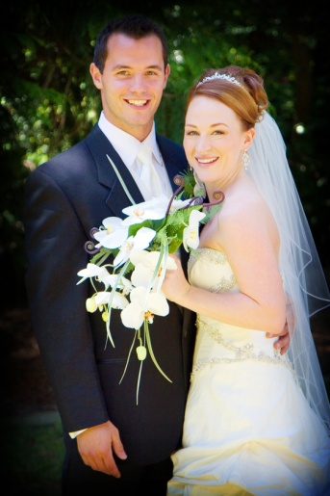
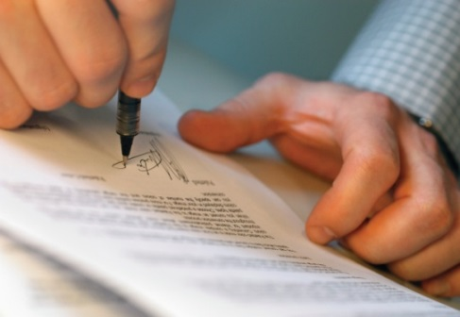

Vocabulary Practice!
Look at the list of words. Circle all of the words you already know and write your own meaning. For the words you don’t know, find the words in the PLS Learning about the Law wikibook, section on Learning About Family Law, or in the PLS Learning About the Law (Family Law, Young People and the Law, Elder Law) booklet, section on Family Law.

spouse
civil
common-law
legal
adultery
divorce
breakdown
intention
permission
file
court order

Say it!
Mark the syllables and word stress on the words below. Practice saying these words with the correct word stress.

married mar’ ried
divorce
separated
civil
common-law
legal
adultery
breakdown
intention
permission
court order

Compare and Share!
In groups, practice comparing and contrasting the topics below.

Comparing & Contrasting
Useful words/phrases to compare
- same
- the same as
- similar to
- both
- as ____ as
- -er/more
- too
Useful words/phrases to contrast
- (very, quite, extremely) different than/from
- unlike
- not at all alike
- opposite
- whereas
- on the other hand

“Watching TV is similar to going to the movies. Both are relaxing forms of entertainment.”
“Watching TV is cheaper than going to the movies but movie theatres are more exciting than staying at home.”
“Watching TV is very different than going to the movies. In the movie theatre the screen is very large and the sound quality is great, whereas a TV does not have good sound quality.”
Topics:
getting married in Canada/getting married in your home country | legal marriage / common law relationship
going to court/making an agreement | agreement when you live together/agreement when you separate
divorce/  separation | Family Law Act/ Divorce Act

Read and Take Notes!
Read the PLS Learning about the Law wikibook, section on Learning About Family Law, or the PLS Learning About the Law (Family Law, Young People and the Law, Elder Law) booklet, section on Family Law. Fill in notes about the following family laws in Canada and your home country.
Family Laws | Canada | My home country
being married
getting separated
getting divorced

Discuss! With a partner from a different country, compare which laws are similar and which ones are different in your countries and report to the class.
Find out More!
Use a computer at school or at home to find out the following information. Visit the Legal Services Society’s Family Law website at http://www.familylaw.lss.bc.ca/ and find the following information (Hint: Look for a search bar or find the FAQ section.)

Can I get legal aid for my family law problem?
- Can you get legal aid for a family law problem? ________________________________________________________________________________________________________________________________________________
- At what age can children choose which parent they will live with? ________________________________________________________________________________________________________________________________________________
- Can you have the paternity test done before the baby is born? ________________________________________________________________________________________________________________________________________________
- When can you stop paying child support? ________________________________________________________________________________________________________________________________________________

What did you learn?
Fill this out on your own.
 | Yes, I can do this on my own. | I need to review this. | I can’t do this yet.
I can understand key terms about family laws in Canada.
I can read in order to find information and take notes on family laws in Canada.
I can compare laws in Canada with laws in my home country.
I can listen and understand others in order to make comparisons.
I can research and find information online.

What else did you learn today? What other questions do you have about Family Law in Canada? _____________________________________________________________________________________________________________________________________________________________________________________________________________________________________________________________________________________________________________________________________________________________________________________________________

Vocabulary Practice!
ANSWER KEY AND DEFINITION CARDS

spouse | someone you are married to or living with in a marriage-like situation
civil | related to citizens; non-religious; public or political
common-law | a marriage-like relationship between two people who have lived together for many years
legal | allowed by law
adultery | the act of being unfaithful to a marriage partner; having sexual relations with someone you are not married to
divorce | the legal separation of two people who were married
breakdown | fail; stop working
intention | plan of action; goal; aim
permission | agreement; allowed to do something by someone
file | to make an application; to arrange
court order | a command by a judge to do something

Say it!
ANSWER KEY

married ma’ rried
divorce di vorce’
separated se’ pa ra ted
civil ci’ vil
common-law co’ mmon law’
legal le’ gal
adultery a dul’ ter y
breakdown break’ down
intention in ten’ sion
permission per mi’ ssion
court order court’ or’ der

All images retrieved from: http://office.microsoft.com/en-us/images/?CTT=6&ver=14&app=winword.exe

