Talking to the Police
Lesson: What Happens When a
Crime is Committed?

CLB 7-8 Instructional Package

CLB Outcomes
CLB 7-I: Interacting with Others | Participate in less routine social conversations for many everyday purposes (such as expressing and responding to appreciation, complaints, satisfaction, dissatisfaction and hope).
CLB 8-IV:Comprehending Information | Understand moderately complex extended descriptions, feature articles, reports and narrations.
CLB 8-III Getting Things Done | Complete an extended range of forms, including extended application forms and workplace forms with pre-set formats.
Content Outcomes
- Understand the legal and social conventions of interacting with the police, including expectations regarding witnesses of crime
- Identify the roles and processes involved in going to court as a witness

Resources
- People’s Law School (PLS) Fact Sheet, Talking to the Police (also available in hardcopy, published 2014)
- PLS worksheets “Talking to the Police: What Happens When a Crime is Committed”
- Computer Lab (optional)

External Resources and Referrals
- For more information on policing in BC, visit the Ministry of Justice at http://www.pssg.gov.bc.ca/policeservices/.
- Invite a police officer to visit your school or visit a Community Policing Centre

Assessment Plan and Tools
- Self-assessment checklist

Sample Lesson Plan
Time | Tasks | Expected Outcome | Resources
15’ | Warm up  - In pairs or small groups, students discuss the pictures  - Go over vocabulary, if needed  - Assess level of knowledge of/ interest in policing in BC | Generate interest  Activate prior knowledge | PLS Worksheet:  Get Ready!
15’ | Predict and read  - Copy and cut cards  - Students put the cards in categories  - Students confirm their predictions by reading the PLS Fact Sheet  - Students discuss scenarios of interacting with police | Identify basic phrases used by the police and public when interacting with each other | PLS Worksheet:  Predict!  PLS Talking to the Police Fact Sheet
15’ | Read for details  - If needed, model summarizing concisely  - This activity can be done as a jigsaw (assign the sections to different students who summarize and share their information) | Understand extended descriptions | PLS Worksheet:  Summarize it!  PLS Talking to the Police Fact Sheet
30’ | Extended role play  - In small groups, students script and plan a dramatization of a scene from the PLS booklet  - Monitor, coach, and support students in their preparations | Work as a team  Practice interacting in formal and less routine situations | PLS Worksheet:  Act it Out!
20’ | Fill it out  - Discuss police misconduct; review booklet for examples of what limits there are on police behavior  - Students identify assessment criteria for the task  - Students fill in a sample form from the Office of the Police Complaint Commissioner (PDF or online)  - Students assess their own and a peers achievement of the task | Complete an extended form which includes answers of up to a paragraph long | PLS Worksheet:  Fill it Out!  Computer lab (optional)
10’ | Discussion  - Students talk about the relationship between the police and the public in small groups, including cross-cultural analysis | Think critically  Express opinions | PLS Worksheet:  Think about it!
20’ | Research  - Individually or in pairs, students research a topic of interest related to policing  - Students share their information with the class | Find out more about policing in BC | PLS Worksheet:  Find out More!  computer lab
TBD | Field Trip or Guest Speaker  - Visit a Community Policing Centre  - Invite a representative from your Community Policing Centre to come to your school  - Contact a School Liaison Officer to talk about the work they do in your local high school | Meet a police officer | PLS Worksheet:  Connect!
10’ | Self-Assessment  - Allow students to fill out self-assessment form independently | Self-assessment | PLS Worksheet: What did you learn?

Get Ready!
Look at the pictures below.

What is happening?
What do you think the people are saying?
What is going to happen next?

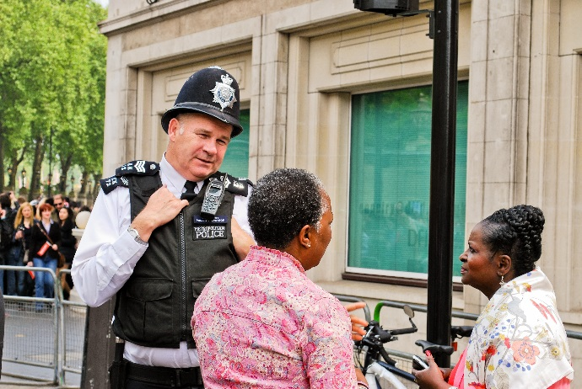
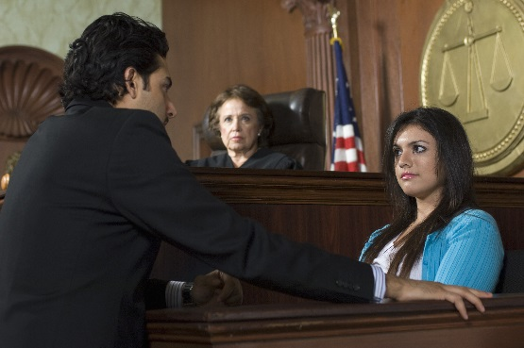

Predict!
Copy and cut these into strips. Get your students to categorize them into things a police officer or a member of the public might say.

Police Officer | Member of the Public | Neither / Never
Can I see your driver’s license and registration, please? | Do you have a warrant to enter my home? | Here’s fifty bucks if you let me go this time.
The crown counsel will send you a subpoena, which will explain when you need to go to court. | Can I get out of the car? | Both / Either
Did you see or hear anything? | I don’t speak English very well. Can I write it in my language? | I’ll have a large double double.
Why didn’t you pull over when I put on my flashing lights? | That’s him. That’s a picture of the guy that robbed me. | Please sit down.

With your group, talk about each statement. In what context might someone say it? Think of a situation that would make sense. Where? When? Who? Why? Are any of these statements typically Canadian? How so?
Read!
Students can confirm their predictions by scanning the PLS Talking to the Police Fact Sheet for information.
Summarize it!
To make information easier to understand, we usually organize it into sections and give each section a descriptive title. Below are the titles of the sections in the PLS Fact Sheet Talking to the Police. Work with your classmates to summarize each section as concisely as possible.
What is Criminal Law? | What to Do if the Police Stop Your Car | Role of Police in Canada
What if a Crime Happens to You? | What If You See a Crime Happening? | Police at Your House
A Witness in Court | Identification | Innocent Until Proven Guilty
Arrest | Going to Court | Living with a Criminal Record
Help for Victims and Witnesses

Act it Out!
Role play the scenarios described in the fact sheet. If you prefer, you can write your own scenarios. In small groups, prepare a dramatic re-enactment of the scenarios. Consider the following elements:

Characters – who is in the scene? who will play each role?
Setting/Scenery – where does the scene take place? how can you represent that place using what is available to you in your classroom?
Props – are there any objects that you could use to make your acting more realistic? a notebook for police officers? a book to represent a holy book for taking an oath?
Costumes – are there any cheap and easy costume pieces you could bring to class?
Dialogue – write a script for your scenario, practice it until you have it memorized
Action – script out the actions, practice using the space and making the actions while you deliver the lines
Performance – can you invite another class to be your audience? can you film your production?

Scene 1: Police officers interview Ying Yee in her store after she has been robbed.
Scene 2: Ying Yee identifies the man who robbed her at the police station.
Scene 3: Ying Yee meets with the Crown Counsel at the court house.
Scene 4: Opening scene of the court case. Ying Yee takes an oath to tell the truth.
Scene 5: The Crown Counsel and the defence lawyer ask Ying Yee about the day of the robbery.
Scene 6: Police officers arrest Jim as he is fleeing the scene of a robbery.

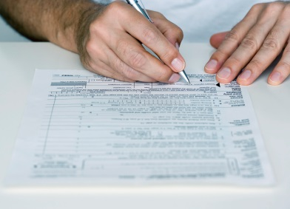
Fill it Out!
Practice filling out extended forms.
In Canada, if a police officer hits you or calls you bad names, you can complain.
Before you begin
- What information do you think you will be asked to provide on the form?
    - your details?
    - details of the incident?
- Imagine a scenario that you can use as your “practice” complaint. Hint: Keep it simple and non-violent.
- To “complete a form” is a language competency (i.e. something you need to be able to do in English). How would you define successful achievement of this competency?
    - fills in all the required information
    - spells correctly
    - uses correct punctuation, capitalization, dates, numbers, and abbreviations
    - other?
Practice filling out a form
To make a complaint about police in BC, go to the Office of the Police Complaint Commissioner at www.opcc.bc.ca/ and click on File a Complaint. From there, you can practice filling out the online form (but do not click the “Submit” button), or if you prefer, you can download and print the PDF version of the form.
After you have finished: Compare your form with a partner. Did they fill out the form successfully? How could you or your partner done better on this task?

Talk about it!
- How does talking to the police in BC compare to talking to police in your country of origin? Is there any difference in people’s attitude towards the police?
- Are the rules governing police behaviour tougher here or there?
- Does the average law-abiding citizen interact with the police very often? In BC? In your country of origin?
- If you witness a crime, would you contact police? Why or why not?
- Have you heard about any situations of police misconduct recently? What impact do those cases have on society?
Find out More!
Use a computer at school or at home to research a policing topic of your choice. Share your information with your classmates.
- The history of the RCMP
- Municipal and provincial police forces
- Recruitment criteria for the RCMP
- Community Policing Centres
- Auxiliary Reserve Police
- Crime Stoppers
- School Liaison Officers

Connect!
Prepare a list of questions and then make arrangements to meet a police officer:
- Visit a Community Policing Centre.
- Invite a representative from your Community Policing Centre to come to your school.
- Contact a School Liaison Officer to talk about the work they do in your local high school.
What did you learn?
Fill this out on your own.
 | Yes, I can do this on my own. | I need to review this. |  | I can’t do this yet.
I can identify some of the rules and expectations of talking to the police.
I can identify the roles, procedures and expectations of going to court as a witness.
I can get information from this kind of informational text.
I can fill in an extended form.
I can interact with people in unusual and formal situations.

What else did you learn today? What other questions do you have about policing in BC?

Image by Shutterstock.com/Nadiia Gerbish
Image of form downloaded from Microsoft clip art.

