Scams to Avoid

CLB 7-8 Instructional Package

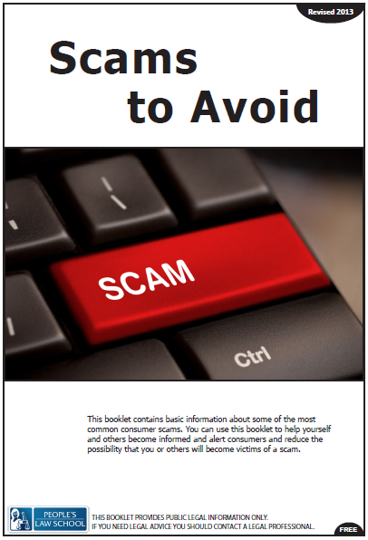
Lesson Plan: Scams to Avoid (CLB 7-8)
CLB Outcomes
CLB 8-III: Getting Things Done | Understand communication intended to influence or persuade (such as extended warnings, threats, suggestions, recommendations and proposed solutions) in situation related to personal decisions or to work-related issues in own field.
CLB 7-III: Getting Things Done | Give extended warnings, suggestions, recommendations or advice.
CLB 7-IV: Comprehending Information | Understand moderately complex extended descriptions, reports and narrations on familiar a topics.
CLB 7-II: Reproducing Information | Reduce short oral discourse (such as live or recorded phone messages, pre-recorded public information, podcasts or short presentations) to notes.

Content Outcomes
- Describe identity theft and scams and how to avoid them
- Give warnings advice about how to recognize scams
- Identify what you can do to minimize the risk of identity theft or being scammed

Resources
- People’s Law School (PLS) Consumer Law Wikibook or Scams to Avoid booklet (hardcopy, published 2013)
- PLS worksheets “Scams to Avoid: Identity Theft”
- Computer Lab (optional)

External Resources and Referrals
- For more information on scams visit the Canadian Anti-Fraud Centre (CAFC) at www.antifraudcentre-centreantifraude.ca.
- Invite a personal security and identity theft expert to the class (or watch online experts talk about personal security and identity theft)

Assessment Plan and Tools
- Self-assessment checklist
Sample Lesson Plan
Time | Sample Tasks | Expected Outcome | Resources
5’ | Warm up  - In small groups, students look at the word map and discuss the words and how they relate to scams  - Go through any vocabulary as needed  - Students discuss the questions at the bottom of the worksheet  - Assess level of knowledge of/ interest in identity theft and scams | Generate interest  Activate prior knowledge | PLS Worksheet:  Get Ready!
20’ | Vocabulary practice  - Use the word cards and choose an activity to use with your class  - Go through any new words but encourage students to check the PLS booklet and guess the words from context first | Understand key terms for the topic of scams | PLS Worksheet: Vocabulary Focus!  PLS Worksheet: Vocabulary Word Card Activities!
20’ | Pronunciation practice  - Review or teach thought grouping, pausing and intonation with students in order to prepare them for their presentations  - Explain the following:  - In order to be comprehensible, English speakers pause with their voice  - Pauses may be longer or shorter depending on what the speaker wants to emphasize  - Go through the rules of where NOT to pause on the worksheet and explain that these groups of words separated by pauses can be called through groups or intonation units  - The prominent point is the stressed syllable of a content word that receives more stress than the other stressed syllables  - It’s at this point where the intonation pattern takes a jump and falls or continues to rise  - Review the rise-fall and rising intonation patterns of English – rise-fall for statements and information questions, rising for clarification and yes/no questions.  - Students mark up the introduction to indicate the pauses, prominent points in the thought groups, and the intonation pattern of each thought group  - Students practice reading the introduction in pairs, focusing on accurate pronunciation | Prepare for oral presentations  Practice clear pronunciation in order to be comprehensible to listeners | PLS Worksheet:  Speak Clearly!
45’ | Presentation practice  - Place students into groups of 3  - Assign one scam to each group  - Go through the instructions at the bottom of the worksheet  - Students create a visual poster representing the information on their topic  - Students present their topic, along with the poster to the class  - Other groups listen and come up with a question to ask the presenters at the end of the their presentation | Understand moderately complex extended descriptions related to scams  Listen in order to engage and ask questions to obtain further information | PLS Worksheet:  Read and Present!  PLS Consumer Law Wikibook or Scams to Avoid booklet
25’ | Role plays  - Go through the language of warnings and advice by using the phrases in the box on the worksheet  - In pairs, assign or have students choose one situation to role play  - Have students perform their role play in front of the class  - Discuss any further warnings and advice the class would give for the situations | Give advice and warnings to friends about scams | PLS Worksheet:  Give Advice!
20’ | Find out More  - Students discuss questions at the top of the worksheet in pairs  - Students navigate through the website www.equifax.com to find information and answer questions  - Check answers as a class | Locate a specific form online and understand the details of the form | PLS Worksheet:  Find out More!  Computer lab www.equifax.com
30’ | Research  - In class or for homework, students conduct an internet search for a news report (up to about 15 minutes) about identity theft  - Students take notes then write a summary of the news report  - Students can share their summaries in class or hand in for feedback | Understand presentation on topic that is generally familiar  Reduce short oral discourse to notes | Computer Lab
10’ | Self-Assessment  Allow students to fill out self-assessment form independently | Self-assessment | PLS Worksheet:  What did you learn?

Get Ready!
Look at the words below. What do you know about scams? How do these words relate to scams? Discuss your ideas.
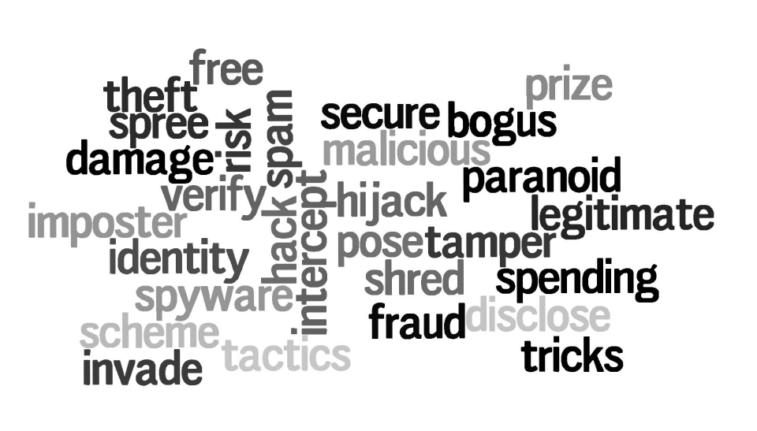

Discuss!
What is identity theft? Do you know anyone who has been a victim of identity theft or a scam? What types of scams occur in your country?
Vocabulary Focus!
Use the words cards below to practice vocabulary related to identity theft, scams and how to avoid them. Choose an activity from the list on the next page.
cut up | run up | spending spree
steal | pose | identity
tamper | retrieve | bogus
pretend | hack | tricks
statements | bills | aware
collection | notice | arrested
fish | fraud | paranoid
passwords | agencies | spam
privacy | links | deleted
keypad | intercept | carry
SIN | legitimate | shred
spam | destroy | report

Vocabulary Word Card Activities!
Copy and cut up the word cards. Choose one of the activities for your class
Small group activities
Materials: set of word cards for each group
Easy: Students work in groups of four. Give each group a set of cut-up word cards. The cards are placed face down in a stack on the table. The first student takes the top card and uses the word in a sentence related to identity theft. If student is having difficulty, group members help out. Students refer to notes and booklet only if the group cannot remember the word. The second student takes the next word card, and so on.
Difficult: Students work in groups of four (A, B, C and D)
• A and B are playing – A reads the card, B uses the word in a sentence related to identity theft. If B cannot use the word in a sentence, he says PASS and A reads the next card.
• C is the timer. Game time limit is 2 or 3 minutes.
• D is judge keeping track of how many words are used correctly in a sentence related to identity theft.
• After the first round, students change roles. The student with the most words used correctly wins.

Large group activities

Connect Four
Materials: white board or overhead and word cards
Draw a 5 by 5 or 6 by 6 grid on the board and number the squares. Divide the class into teams of five. The goal of the game is to connect four squares in a straight line. First team chooses a square. The teacher reads the word. The team must use the word correctly in a sentence related to identity theft and scams. If the team is unable to do so, the next team can steal the square by correctly using the word in a sentence. A point is given for each four in a row. The team with the most points wins.

Quick Draw Password
Materials: word cards and a ball on a table
Divide the class into two teams. The first person from each team comes to the front. The teacher reads the word. The student who grabs the ball from the table first gets to answer i.e. use the word in a sentence related to identity theft and scams. If the student is unable to do so, the other student on the opposing team can steal the point by using the word correctly in a sentence. The next two students come to the table for the next round. The team with the most points wins.
Speak Clearly!
Mark the following presentation introduction with lines to indicate pauses, a dot to indicate the prominent point in the thought group, and or to indicate the rise-fall or rising intonation pattern from the prominent point. Practice reading it aloud with a partner.

Thought Groups in English
Where NOT to pause: | Example
between a noun and a verb | Consumer laws protect
in the middle of a noun phrase | a written contract
between a preposition and its object | in the law office
in the middle of a verb phrase | has been working

Presentation Introduction
“Hello everyone. Today I would like to talk to you about a very serious type of scam. Take a look at this poster. What does it tell you? Did you know that people can steal your identity and use it to go on spending sprees? Identity theft is a serious problem. There are many ways that your identity can be stolen. I will talk about a few of those ways today and give you some tips on how to avoid being scammed.”

Read and Present!
You are going to imagine that you are part of a campaign to stop scammers. In your group, you will research one of the types of scams in order to present your findings at the campaign meeting. Follow the instructions outlined below. As you listen to other presentations, come up with one question to ask.

1. Research the sections on scams and identity theft in the PLS Consumer Law Wikibook, or the Scams to Avoid booklet, for your type of scam. If possible, search the internet for further information about your type of scam.
2. Create a visual poster to represent the scam and to summarize your ideas.
3. Present your information at the campaign meeting (no more than 5 minutes) and include the following:
  - Describe the type of scam
  - Explain how it happens
  - Provide instructions on how to avoid this type of scam

- Allow time for questions.
Give Advice!
Look at the situations below. With a partner, chose one situation and create a conversation role play to give advice or warnings about identity theft and scams. Use the phrases in the box as a guide for your conversation. Present your role play to the class.

Warnings & Advice
Giving warnings
- You need to be careful of ___
- Watch out for ___
- I wouldn’t ___ if I were you because___
- You should be aware of/that
- I’d be careful of ___if I were you.

Suggestions & Advice
- You should ___
- I suggest that___
- Be sure to ___
- Don’t ___
- Never ___
- I strongly advise you to ___

Situation 1:
John just signed up for a new credit card. He told you that he got a phone call yesterday from a company that said they needed his SIN number in order to verify some information. He wonders if he needs to provide it in order to get the credit card.
Situation 2:
You are in the computer lab with your friend Tanya. She told you that she just got a friend request on Facebook from someone but she is not sure who it is. This person sent her a link to an interesting website and she is curious to see what it is.
Situation 3:
Julie was house cleaning and has put all of her paper files and bank statements in a garbage bag to throw out. You come to her place just as she is about to put out her garbage.
Situation 4:
Tim received an email about a free subscription to a health product and is interested to try it out. He tells you about the product and then mentions that they asked for his credit card as a backup but they won’t charge him.

Find out More!
Go to www.equifax.com and answer the following questions. Find the free credit file request form “Request to Obtain My Free Credit Report” and answer the following questions.
- What is a credit report?
- What services does Equifax provide?
- How do you get a credit report?
- What personal information or identification does Equifax request?
- How will Equifax use the information to confirm your identity?
- How may Equifax use your personal information?
- What pieces of information are optional?
- When should you receive your credit report?
- Would you use Equifax? Why or why not?
Talk about It!
Discuss the following questions with a partner.
Is identity theft a problem in your country?

Do you know anyone who has had their identity stolen? If yes, what happened?

Insurance companies now sell Identity Theft Insurance. What do you think this insurance provides? Would you buy this insurance? Why or why not?

Research!
Go to YouTube or research online to find a news report about identity theft. Take notes and then write a summary of the news report. Share your summary with a classmate.

What did you learn? Fill this out on your own.
 | Yes, I can do this on my own. | I need to review this. | I can’t do this yet.
I can explain what identity theft and scams are and list the warning signs.
I can give a clear oral presentation and respond to questions.
I can give advice and warnings to friends about identity theft and scams.
I can locate forms and information online.
I can write a summary of an oral report.

What else did you learn today? What other questions do you have about scams? ______________________________________________________________________________________________________________________________________________________________________________________________________________________________________________________________________________________________________________________________________________________________________________________________________

Speak Clearly!
ANSWER KEY
Thought Groups in English
Where NOT to pause: | Examples:
between a noun and a verb | Consumer laws protect
in the middle of a noun phrase | a written contract
between a preposition and its object | in the law office
in the middle of a verb phrase | has been working

Presentation Introduction
“Hello everyone. Today I would like to talk to you( ) about a very serious problem. Take a look at this poster. What does it tell you? Did you know that people can steal your identity( ) and use it to go on spending sprees? Identity theft is a big problem. There are many ways that your identity can be stolen. I will talk about a few of those ways today and give you some tips on how to avoid being scammed.”

NOTE: The pause in brackets () is optional. Student may add more pauses than are indicated above. Allow for other pauses as long as they are natural and follow the rules above for where NOT to pause.

