Talking to the Police
Lesson: What Happens
When a Crime is Committed?

CLB 5-6 Instructional Package

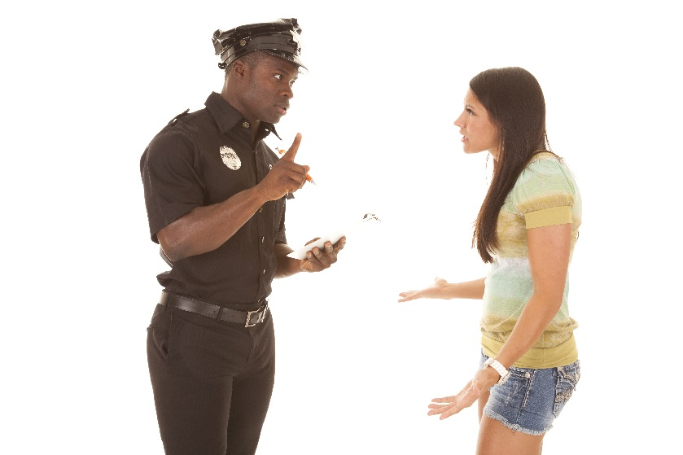

CLB Outcomes
CLB 5-III: Getting Things Done | Give and respond to informal requests, permission, suggestions and advice.
CLB 6-IV: Comprehending Information | Understand moderately complex descriptive or narrative texts on familiar topics.
CLB 5-III Getting Things Done | Complete forms requiring detailed personal information.

Content Outcomes
- Understand the legal and social conventions of interacting with the police
- Identify the process of making a complaint against the police

Resources
- People’s Law School (PLS) fact sheet, Talking to the Police available at http://wiki.clicklaw.bc.ca/index.php/Talking_to_the_Police_Lesson_Module
- PLS worksheets “Talking to the Police: What Happens When a Crime is Committed”
- Computer Lab (optional)

External Resources and Referrals
- For more information on policing in BC, visit the Ministry of Justice at http://www.pssg.gov.bc.ca/policeservices/.
- Invite a police officer to visit your school or visit a Community Policing Centre

Assessment Plan and Tools
- Self-assessment checklist

Sample Lesson Plan
Time | Sample Tasks | Expected Outcome | Resources
15’ | Warm up  - In pairs or small groups, students discuss the pictures  - Go over vocabulary, if needed  - Assess level of knowledge of/ interest in policing in BC | Generate interest  Activate prior knowledge | PLS Worksheet:  Get Ready!
15’ | Predict and Read  - Students predict answers to questions and vocabulary about talking to the police  - Students confirm their predictions by reading the first few sections of Talking to the Police | Provide conceptual framework and activate vocabulary needed to understand text | PLS Worksheet: Predict!  Talking to the Police
15’ | Vocabulary  - Students identify words that refer to a person and then use them to complete sentences  - Students identify verbs and then use them to complete sentences | Extend understanding of words encountered in text | PLS Worksheet: Build your Vocabulary!
30’ | Give advice  - Students analyze sentences and identify suggestion, permission, obligation  - Students analyze modal verbs and identify how they are used  - Students practice the grammar of giving advice and then practice giving advice | Analyze the use of modals for suggestion, permission, obligation  Give advice | PLS Worksheet:  Give Advice!
20’ | Fill it Out  - Discuss police misconduct; review booklet for examples of what limits there are on police behavior  - Students fill in a sample form based on the actual form from the Office of the Police Complaint Commissioner | Complete an extended form | PLS Worksheet:  Fill it Out!
10’ | Discussion  - Students talk about the relationship between the police and the public in small groups, including cross-cultural analysis | Think critically  Express opinions | PLS Worksheet:  Talk about it!
20’ | Research  - Individually or in pairs, students research a topic of interest related to policing  - Students share their information with the class | Find out more about policing in BC | PLS Worksheet: Find out More!  computer lab
TBD | Field Trip or Guest Speaker  - Visit a Community Policing Centre  - Invite a representative from your Community Policing Centre to come to your school  - Contact a School Liaison Officer to talk about the work they do in your local high school | Meet a police officer | PLS Worksheet: Connect!
10’ | Self-Assessment  - Allow students to fill out self-assessment form independently | Self-assessment | PLS Worksheet: What did you learn?

Get Ready!
Look at the pictures below.
What is happening?
What do you think the people are saying?
What is going to happen next?

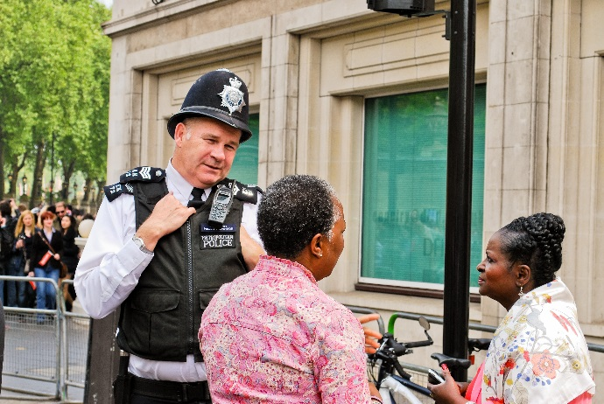
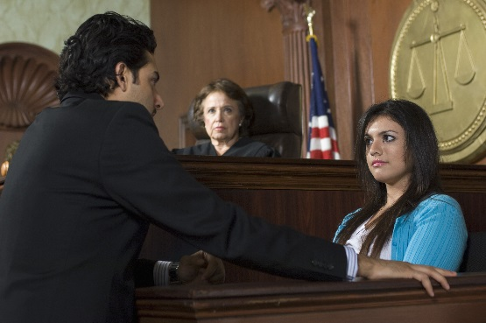

Predict!
You are going to read part of a booklet called, Talking to the Police. Here are some questions that will be answered in the text. Can you guess what the answer will be? Can you guess some words you will read?

Question | Possible Answer | Vocabulary
What is criminal law? | rules about not hurting people or stealing things | kill, steal, rob, break the law, court
What should you do if the police stop your car?
When can the police enter your home?
What happens if you see a crime happening?
What if a crime happens to you?

Read!
Scan the first few sections of the booklet to check your answers.

Build your Vocabulary!
Who’s who? Which of these words refer to a person?

criminal
illegal
officer
obey
duty
complaint
pull over
ownership
bribe
a warrant
witness
interpreter
arrest
victim
identify

Who’s who? Use the words from the list above.
- Jennifer saw a man hit a parked car with his car, and then drive away. She is a _____________________________.
- Tom’s house was broken into and his laptop was stolen. He is a _____________________________.
- Sandy works for the RCMP. She is a police _______________________________.
- Amber can communicate fluently in both English and Farsi. She helps the police when they are trying to talk with someone who only speaks Farsi. She is an _____________________________.
- Ben steals cars. He is a _______________________________________________.

Build your Vocabulary!
Who’s does what? Which of these words refer to a verb (an action)?

criminal
illegal
officer
obey
duty
complaint
pull over
ownership
bribe
a warrant
witness
interpreter
arrest
victim
identify

Who’s does what? Use the words from the list above. Change the form of the verb to suit the meaning of the sentence.
- The speeding driver ____________________ (not) the red light, and went through the intersection without stopping.
- When the police want you to ____________________________ while you are driving, they will flash their blue and red lights and sound their siren.
- The witness ________________________ the man who stole her bag by pointing to his picture at the police station.
- The police officers _____________________ Ben for stealing a car.
- In Canada, it a serious offence to try to ____________________ a police officer.

Give Advice!
Use should, can, must and have to when giving someone advice about how to talk to the police in Canada and describing rules and laws.
Read and discuss the sentences below.
- Which sentences are about suggestions? (i.e. saying that something is a good idea to do) How do you know?
- Which sentences are about permission? (i.e. saying that someone is allowed to do something) How do you know?
- Which sentences are about obligation (i.e. saying that something is a rule or law)
- Which sentences are the strongest? weakest? How do you know?
- Which sentences mean that there is a choice? How do you know?

- If a police officer hits you or calls you bad names, you can make a complaint.
- You must never offer the police money.
- If you see a crime happening, you should call the police.
- In Canada, the police have to obey the law.
- The police can come into your house if they have a warrant.
- If you are a witness to a crime, you should give the police any information that can help them.
- When you are driving a car, and you see a police car with flashing lights behind you or driving beside you, you must stop at the right side of the road.
- The police can come into your house if they think a serious crime is happening in your house.
- If you are stopped by a police officer while driving, you have to show your driver’s license.

Give Advice!
Use should, can, must and have to when giving someone advice about how to talk to the police in Canada and describing rules and laws.

Think about how we use these modal verbs. Put the statements under the words they apply to. Some may apply to more than one modal verb.

should |  | can |  | must |  | have to
use to state an obligation |  | there is no choice |  | say that something is a good idea |  | use to state permission
there is a choice |  | use to make a suggestion |  | not often used in spoken English |  | your thoughts?

Give Advice!
Use should, can, must and have to when giving someone advice about how to talk to the police in Canada and describing rules and laws. Practice saying the sentences using the correct modal verbs. Cut these sentences into strips.
If a police officer hits you or calls you bad names, you _____ make a complaint.
You ______ never offer the police money.
If you see a crime happening, you ________ call the police.
In Canada, the police _________ obey the law.
The police _________ come into your house if they have a warrant.
If you are a witness to a crime, you _______ give the police any information that can help them.
When you are driving a car, and you see a police car with flashing lights behind you or driving beside you, you _________ stop at the right side of the road.
The police _________ come into your house if they think a serious crime is happening in your house.
If you are stopped by a police officer while driving, you ________ show your driver’s license.

Suggestions for practicing
- True or False - Can you remember the information correctly? Test each other.
- Grammar Drill – Can you change these statements into questions? How about negatives (Can you keep the meaning the same)?
- Role Play – With a partner, pretend one of you is giving advice to the other about how to talk to police in Canada.
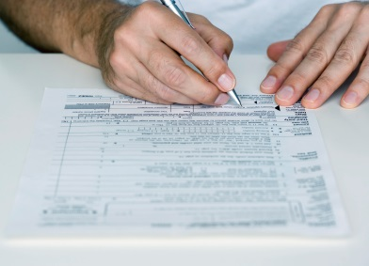
Fill it Out!
Practice filling out forms.
In Canada, the police have to obey the law. Their duty is to protect the people in the community. There are rules for the police. If a police officer hits you or calls you bad names, you can complain.

Jacob Singh, 25, was walking home one evening when the police stopped him and asked to look in his bag. He didn’t know why they were asking him to do that so he said no. The officers told him to open his bag. Jacob started walking away from the officers. They ran after him and grabbed his arm. He fell to the ground and hurt his knee and his arm. After the police officers looked in his bag, and didn’t find anything illegal, they let him go home. The next day Jacob decides to make a complaint against the police.

Fill in the form on the next page using the information given in the story about Jacob. Use the school address and phone number.

COMPLAINT FORM |  |  | OFFICE OF THE POLICE COMPLAINT COMMISIONER
*Indicates this information is required in order to process your complaint. Please be as precise as possible.
YOUR DETAILS
Last Name:* |  |  |  | First Name:*
Title:* |  |  |  | Date of Birth: (Y/M/D)
Telephone / Email: |  |  |  | Mailing  Address:
* Please provide at least 1 way in which we can contact you *
THE INCIDENT
When did the incident happen (date and time)? *
Where did the incident happen? *
Name of the Police Department involved: * Police File # (if known):
Name or badge number of Officer(s) – if known:
Were there any witnesses? If so, please list their names and contact information (if known):

Talk about it!
- How does talking to the police in BC compare to talking to police in your country of origin? Is there any difference in people’s attitude towards the police?
- Are the rules governing police behaviour tougher here or there?
- If you witness a crime, would you contact police? Why or why not?

Find out More!
Use a computer at school or at home to research a policing topic of your choice. Share your information with your classmates.
- The history of the RCMP
- Municipal and provincial police forces
- Recruitment criteria for the RCMP
- Community Policing Centres
- Auxiliary Reserve Police
- Crime Stoppers
- School Liaison Officers

Connect!
Prepare a list of questions and then make arrangements to meet a police officer:
- Visit a Community Policing Centre.
- Invite a representative from your Community Policing Centre to come to your school.
- Contact a School Liaison Officer to talk about the work they do in your local high school.
What did you learn? Fill this out on your own.
 | Yes, I can do this on my own. | I need to review this. | I can’t do this yet.
I can identify some of the rules and expectations of talking to the police.
I can get information from this kind of informational text.
I can fill in a form.
I can give advice using the correct modal verbs.

What else did you learn today? What other questions do you have about policing in BC? ______________________________________________________________________________________________________________________________________________________________________________________________________________________________________________________________________________________________________________________________________________________________________________________________________

Build your Vocabulary!
ANSWER KEY
Who’s who? Which of these words refer to a person?

criminal
illegal
officer
obey
duty
complaint
pull over
ownership
bribe
a warrant
witness
interpreter
arrest
victim
identify

Who’s who?
- Jennifer saw a man hit a parked car with his car, and then drive away. She is a witness.
- Tom’s house was broken into and his laptop was stolen. He is a victim.
- Sandy works for the RCMP. She is a police officer.
- Amber can communicate fluently in both English and Farsi. She helps the police when they are trying to talk with someone who only speaks Farsi. She is an interpreter.
- Ben steals cars. He is a criminal.

Build your Vocabulary!
ANSWER KEY
Who’s does what? Which of these words refer to a verb (an action)?

criminal
illegal
officer
obey
duty
complaint
pull over
ownership
bribe
a warrant
witness
interpreter
arrest
victim
identify

Who’s does what? Use the words from the list above. Change the form of the verb to suit the meaning of the sentence.
- The speeding driver didn’t obey (not) the red light, and went through the intersection without stopping.
- When the police want you to pull over while you are driving, they will flash their blue and red lights and sound their siren.
- The witness identified the man who stole her bag by pointing to his picture at the police station.
- The police officers arrested Ben for stealing a car.
- In Canada, it a serious offence to try to bribe a police officer.

Give Advice!
ANSWER KEY

should |  | can |  | must |  | have to
use to make a suggestion  say that something is a good idea  there is a choice |  | use to state permission  there is a choice |  | use to state an obligation  there is no choice  not often used in spoken English |  | use to state an obligation  there is no choice

¹ images from Shutterstock.com/Nadiia Gerbish.
Image of form downloaded from Microsoft clip art.

