Learning about the Law Lesson: Renting a Home

CLB 5-6 Instructional Package

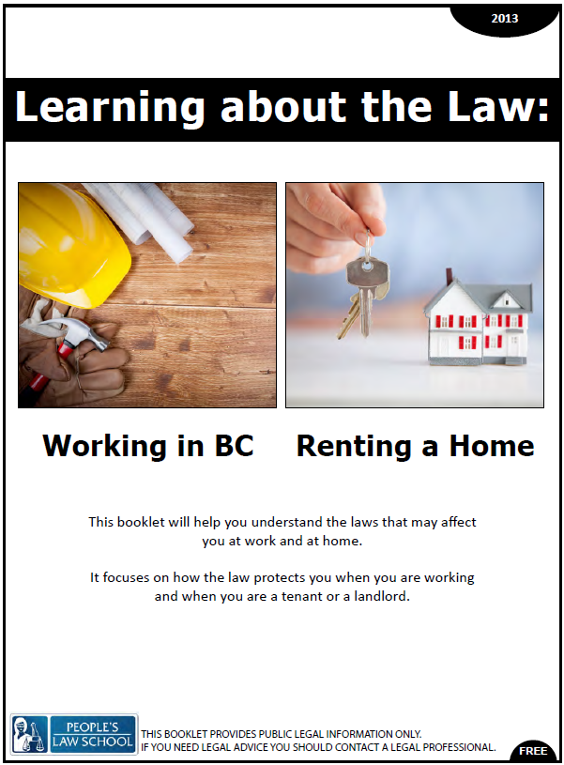

Lesson Plan: Notice of Rent Increase (CLB 5-6)
CLB Outcomes
CLB 5-II: Comprehending Instructions | Understand simple to moderately complex directions and instructions for generally familiar and relevant procedures.
CLB 6-I: Interacting with Others | Participate in routine social conversations for some everyday purposes (such as apologies, excuses, expressing opinions, and making suggestions or arrangements).
CLB 6-III: Getting Things Done | Get information from moderately complex business/service texts containing advice, requests or detailed specifications.
CLB 6-III: Getting Things Done | Write short business or service correspondence for routine purposes.

Content Outcomes
- Identify key rights and responsibilities of tenants when renting a home
- Identify key responsibilities of landlords towards tenants
- Locate and access community and government resources for tenants and landlords
Resources
- People’s Law School (PLS) wikibook, Learning About the Law, section on Renting a Home
- PLS worksheets “Learning about the Law: Renting a Home”
- Computer Lab http://www.rto.gov.bc.ca/documents/RTB-7.pdf

External Resources and Referrals
- Tenant Resource & Advisory Centre (TRAC) www.tenants.bc.ca
- People’s Law School www.publiclegaled.bc.ca (video clips and additional publications)
- Residential Tenancy Branch www.rto.gov.bc.ca
Assessment Plan and Tools
- Self-assessment checklist
Sample Lesson Plan
Time | Sample Tasks | Expected Outcome | Resources
15’ | Warm up  - In small groups , students discuss the words they know and share their experiences of looking for housing in Canada | Generate interest  Activate prior knowledge | PLS Worksheet:  Get Ready!
30’ | Predict and read  - In pairs, students complete the multiple choice questions  - Students scan through the PLS booklet to check answers | Discuss and predict laws related to landlords and tenancy  Skim in order to check comprehension | PLS Worksheet:  Test your Knowledge!  Learning about the Law: Renting a Home, p. 11-15.
45’ | Writing and responding  - In pairs, students take on a role of landlord or tenant and practice filling in a form and writing a letter of response  - Have the landlords use the computer lab to follow the link, print out the form and fill it out  - Review formal letter format for the tenants and have the students follow the template and write a formal letter of response to the landlord  - Students can work together to accomplish both tasks or individually, each taking one task | Read and fill out an online form  Write a formal letter to a landlord | PLS Worksheet: Forms and Letters!  Computer Lab  http://www.rto.gov.bc.ca/documents/RTB-7.pdf  PLS Worksheet: Write a Letter!
35’ | Conversation role plays  - Students work in pairs to role play a conversation between a landlord and a tenant  - Students use the PLS booklet as a guide to practice conversations  - Students perform role plays for the class | Respond appropriately to requests and instructions  Ask questions politely and appropriately  introduce and carry on a short conversation | PLS Worksheet: Conversation Practice!  Learning about the Law: Renting a Home, p. 11 – 15.
10’ | Self- Assessment  - Allow students to fill out self- assessment form independently | Self-assessment | PLS Worksheet: What did you learn?

Get Ready!
Work in small groups. Look at the housing vocabulary below. Discuss what you know about these words. What was important for you when looking for a place to live in Canada? Talk about the first time you looked for a place to live in Canada.
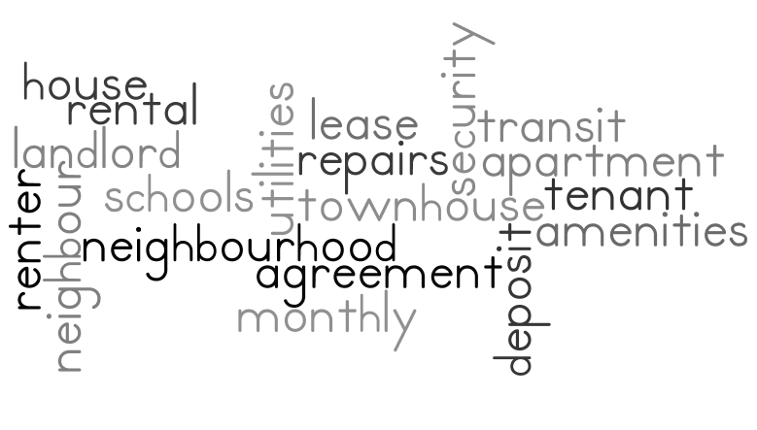

Vocabulary Practice A!
Work with a partner to find the missing vocabulary words.
Partner A:
a person who pays money to rent a place
tenancy agreement
a person who owns property and rents or leases it to others
inspection
an agreement or contract in which money is paid to temporarily rent or lease a house or apartment
security deposit
a person who is licensed to check a property in order to be sure that all laws are followed
eviction
a formal request to a court in order to ask for a decision to be changed
to give notice
Useful Language
- What does eviction mean?
- What/ Who is a person who owns…?
- Pardon? Can you spell that?

Vocabulary Practice B!
Work with a partner to find the missing vocabulary words.
Partner B:
tenant
a legal contract between the landlord and the tenant
landlord
an act of checking that all rules are followed and that everything is satisfactory
lease
money that is paid to the landlord at the beginning of a lease and returned at the end if the tenant does not damage the property
inspector
to legally tell someone that they must leave the house or apartment they are living in
appeal
a written letter to tell a landlord that you will be moving out
Useful Language
- What does eviction mean?
- What/ Who is a person who owns…?
- Pardon? Can you spell that?

Test your Knowledge!
Work with partner to read the questions and choose the best answer. After completing the questions, scan the PLS booklet, p. 11 – 15 to check your answers.
- When you rent a house or an apartment, you
- must give a security deposit which is equal to one month’s rent.
- should make sure you have proof that you paid the rent.
- usually pay rent to the landlord twice a month.
- do all of the above.

- If the landlord wants to increase the rent,
- he/she must give tenants one months’ notice.
- he/she must give tenants two months’ notice.
- he/she must give tenants three months’ notice.
- none of the above

- If the landlord wants to increase the rent,
- he/she must write a letter to the tenant.
- he/she can inform the tenant in a phone call or text.
- he/she must use a special form.
- both a and c

- When the tenant moves out,
- the tenant must tell the landlord in person.
- the tenant should give the landlord an address in writing, saying where to send the security deposit.
- the landlord can use some of the security deposit to repair any damage or to clean up the place without the tenant’s permission.
- all of the above

- If the landlord wants to see the rented house or apartment,
- he/she must give a letter to the tenant 24 hours before entering.
- he/she must call the tenant at least one hour before entering the rented house or apartment.
- he/she can enter without permission any time between 8 a.m. and 9 p.m.
- none of the above

- A landlord can sometimes make a tenant move out. This is called eviction. If you are a landlord, and you need to evict a tenant,
- you only need to give the tenant one month’s notice, regardless the reason.
- you don’t need to have a reason.
- both a and b
- none of the above

- If a landlord wants you to move out,
- you can appeal the eviction.
- you can ignore the eviction.
- you must obey the eviction regardless the length of time of the notice and the reason(s).
- none of the above

- When you are moving out of a house or apartment that you are renting, the law requires that
- you give notice to your landlord in writing.
- you give at least one month’s notice to the landlord if you are in a month-to-month tenancy.
- you may have to pay extra money to the landlord if you are breaking a fixed term tenancy agreement.
- all of the above
Forms and Letters!
Work with partner. One person will be the landlord; the other person will be the tenant. Follow the instructions below.

LANDLORD – Go to the http://www.rto.gov.bc.ca/documents/RTB-7.pdf website and complete the Notice of Rent Increase. Use your school’s address as the rental address and the following as your (the landlord’s) address: 1443 Howe Street, Vancouver, BC, V6Z 2M4. Include the following information:
- Current rent is $1,200 per month
- Rent will increase to $1,300 per month

TENANT - Write a formal letter to your landlord using the template. Your landlord’s rent increase is higher than what the government allows. Politely inform him of the correct and allowable amount for a rent increase. Include the following information:
- acknowledge Notice of Rent Increase
- make reference to the Residential Tenancy Act and the current percentage rent change set by the government
- inform your landlord of the maximum monetary amount he/she is allowed to increase your rent based on your current $1,200/month rent
- include an appropriate salutation, subject line, opening and closing paragraphs, and a complimentary closing

Write a Letter!
Use this format to respond your landlord’s Notice of Rent Increase.
Your name
Address
Date

Recipient’s name
Title
Company Name
Address
Subject
Dear ,

Sincerely,

Your signature

Your name printed

Conversation Practice!

Negotiating
Conversation Openers
- Good morning/afternoon
- Nice day, isn’t it?
- It’s pretty cold, isn’t it?
- I’m glad I ran into you.
Introducing/changing the topic
- By the way, I wanted to talk to you about _____
- I would like to talk to you about _____
Apologizing
- Sorry for…
- I didn’t realize/know…
- I apologize for…
Thanking
- Thanks for letting me know.
- I appreciate…
Asking/Requesting
- Could you _____?
- Would you mind _____?
- I would like ….
Future
- I hope we can …
- In the future, I will…

Use the phrases in the box to role play the following conversations between a landlord and a tenant. Refer to the PLS booklet, p. 11 – 15 for information for your role plays.
TOPICS
- Notice of Rent Increase
The landlord has received the tenant’s letter. The landlord and tenant have a conversation about the rent increase.

- Renting a place
The landlord is showing his/her house to a prospective tenant. They meet at the house and the landlord shows the tenant around. The tenant asks questions to find out more about the house and the lease.

- Damages
There are some damages to the apartment that need to be fixed. The tenant asks the landlord to come and repair the damages. The damages were not caused by the tenant.

- Eviction Notice
The landlord wants to fix up the house in order to sell the property. He/she sent a letter to the tenant. The tenant and landlord have a conversation about the situation

What did you learn?
Fill this out on your own.

 | Yes, I can do this on my own. | I need to review this. | I can’t do this yet.
I can skim and scan to get information from business texts.
I can complete a form requiring detailed personal information.
I can write short business or service correspondence for routine purposes.
I can participate in a conversation apologizing, giving excuse, and making suggestions or arrangements.

What else did I learn today? What other questions do I have about renting a home?

Vocabulary Practice A/B!
ANSWER KEY
tenant | a person who pays money to rent a place
tenancy agreement | a legal contract between the landlord and the tenant
landlord | a person who owns property and rents or leases it to others
inspection | an act of checking that all rules are followed and that everything is satisfactory
lease | an agreement or contract in which money is paid to rent or a house or apartment for a fixed period of time
security deposit | money that is paid to the landlord at the beginning of a lease and returned at the end if the tenant does not damage the property
inspector | a person who is licensed to check a property in order to be sure that all laws are followed
eviction | to legally tell someone that they must leave the house or apartment they are living in
appeal | a formal request to a court or to someone in authority in order to ask for a decision to be changed
to give notice | a written letter to tell a landlord that you will be moving out

Test your Knowledge!
ANSWER KEY
- When you rent a house or an apartment, you
- must give a security deposit which is equal to one month’s rent.
- should make sure you have proof that you paid the rent.
- usually pay rent to the landlord twice a month.
- do all of the above.

- If the landlord wants to increase the rent,
- he/she must give tenants one months’ notice.
- he/she must give tenants two months’ notice.
- he/she must give tenants three months’ notice.
- none of the above

- If the landlord wants to increase the rent,
- he/she must write a letter to the tenant.
- he/she can inform the tenant in a phone call or text.
- he/she must use a special form.
- both a and c

- When the tenant moves out,
- the tenant must tell the landlord in person.
- the tenant should give the landlord an address in writing, saying where to send the security deposit.
- the landlord can use some of the security deposit to repair any damage or to clean up the place without the tenant’s permission.
- all of the above

- If the landlord wants to see the rented house or apartment,
- he/she must give a letter to the tenant 24 hours before entering.
- he/she must call the tenant at least one hour before entering the rented house or apartment.
- he/she can enter without permission any time between 8 a.m. and 9 p.m.
- none of the above

- A landlord can sometimes make a tenant move out. This is called eviction. If you are a landlord, and you need to evict a tenant,
- you only need to give the tenant one month’s notice, regardless the reason.
- you don’t need to have a reason.
- both a and b
- none of the above

- If a landlord wants you to move out,
- you can appeal the eviction.
- you can ignore the eviction.
- you must obey the eviction regardless the length of time of the notice and the reason(s).
- none of the above

- When you are moving out of a house or apartment that you are renting, the law requires that
- you give notice to your landlord in writing.
- you give at least one month’s notice to the landlord if you are in a month-to-month tenancy.
- you may have to pay extra money to the landlord if you are breaking a fixed term tenancy agreement.
- all of the above

