Paying Taxes
Lesson: Income Tax

CLB 4 Instructional Package
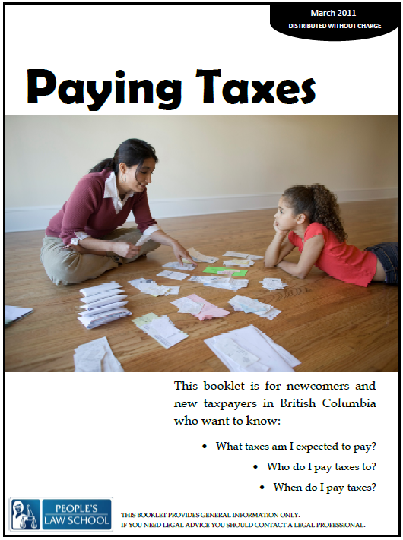

Lesson Plan: Income Tax (CLB 4)
CLB Outcomes
CLB 4-IV:Sharing Information | Give brief descriptions of personal experiences, situations or simple processes, such as getting goods or services.
CLB 4-III:Comprehending Information | Understand the purpose, main idea, key information and specific details in simple, short texts related to everyday familiar and personally relevant situations and topics.

Content Outcomes
- Identify and understand facts and details about income tax and income tax returns
- Identify where to get more information about income taxes in Canada

Resources
- People’s Law School (PLS) booklet, Paying Taxes, p. 3-5
- PLS worksheets “Paying Taxes: Income Tax”
- Computer Lab (optional)

External Resources and Referrals
- For more information on income tax, visit the CRA website at http://www.cra-arc.gc.ca/.
- Invite an accountant to give a brief explanation of the main facts about taxes.

Assessment Plan and Tools
- Self-assessment checklist

Sample Lesson Plan
Time | Sample Tasks | Expected Outcome | Resources
10’ | Warm up  - In pairs or small groups, students discuss the pictures  - Go over vocabulary, if needed  - Assess level of knowledge of / interest in taxes | Generate interest  Activate prior knowledge | PLS Worksheet:  Get Ready!
20’ | Predict and read  - Students work alone or in pairs to fill in the blanks  - Students check their answers by skimming the PLS booklet  - Students discuss questions with a partner  - Go over any information about income taxes if needed | Identify the roles and responsibilities for duties around income taxes | PLS Worksheet:  Predict the Roles!  Paying Taxes,  p. 3-5.
25’ | Read and take notes  - Students read the PLS booklet to find information and facts about income tax and tax returns  - Students share and compare the notes they took and add to their notes  - Go over information with the class | Skim and scan for information in the text | PLS Worksheet:  Read and Take Notes!  Paying Taxes,  p. 3-5.
20’ | Grammar and vocabulary  - Students identify differences in meaning between phrasal verbs and main verbs  - Students practice guess the meaning from the context  - Students practice creating their own sentences with the phrasal verbs | Practice vocabulary learning strategies  Use new vocabulary to create sentences | PLS Worksheet:  Practice Phrasal Verbs!
20’ | Pronunciation practice  - Students practice word stress patterns in phrasal verbs  - Students practice saying sentences and creating their own sentences | Pronounce phrasal verbs with correct word stress | PLS Worksheet:  Say it!
20’ | Pair Q & A  - Students take turns asking and answering questions  - Student practice pronunciation | Pronounce phrasal verbs in sentences  Listen and respond appropriately to questions | PLS Worksheet:  Say it Again!  Paying Taxes,  p. 3-5.
25’ | Find out more  - Students find out more about where they can go for help with income tax  - Students fill out information they learn from the website | Computer Lab  http://www.cra-arc.gc.ca/ | PLS Worksheet:  Find out More!
10’ | Self-Assessment  - Allow students to fill out self-assessment form independently | Self-assessment | PLS Worksheet: What did you learn?

Get Ready!
Look at the pictures. What do these pictures represent? Discuss your ideas with your group.

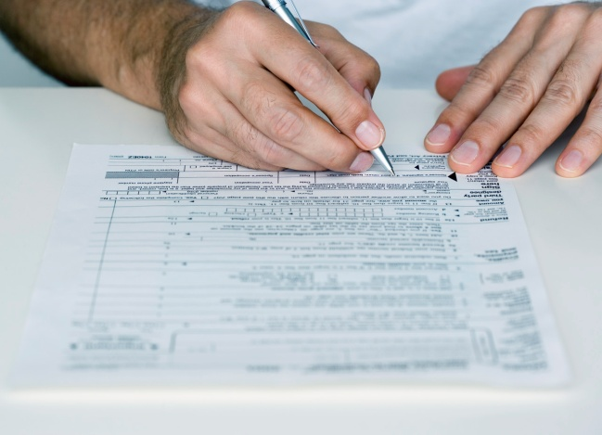
Predict the Roles!
Fill in the blanks below with who is responsible for the duties related to income taxes. Skim the PLS booklet, p. 3-5 to find the answers.

you | your employer
the CRA (Canada Revenue Agency) | an accountant

- Every year, ____________ must pay income taxes.
- When you get a job ____________ fill/s out a tax form.
- ____________ must take tax money off of your check every time you get paid and send it to the government.
- ____________ collect/s taxes for the federal and provincial government.
- ____________ is/are in charge of all income tax.
- You can pay ____________ to fill out your tax return.
- You must tell ____________ how much money you made in a year.

Discuss!
Discuss the following questions with a partner.
- Do you pay income taxes in your country?

- In Canada, taxes pay for services such as roads, parks, health care, schools and police. How are these paid for in your country?

- What do you want to know about income taxes in Canada?

Read and Take Notes!
Skim and scan the People’s Law School booklet Paying Taxes, p. 3 – 5. Work with a partner to find the answers to the questions in the left column and take notes in the other columns. Compare your information with a partner and add to your notes.

 | Income Taxes | Income Tax Returns
What?
Who?
When? |  | - by April 30th  - by June 15th if you have a business
How?/Where?
Why?

Practice Phrasal Verbs!
There are many two or three word verbs in English called phrasal verbs. These verbs consist of a verb plus a particle. The meaning of the main verb changes when the particle is attached to make it a phrasal verb. What is the difference in meaning between these sets of verbs? Find these phrasal verbs in the People’s Law School booklet Paying Taxes, p. 3 -5.
Verb | Examples | Meaning
to drop | He dropped the book on the floor. | released; let go of
to drop off | He dropped off his tax return at the office. | delivered
to work | I have to work at the office today.
to work out | I have to work out how much I owe on my taxes.
to send | Tom sent an email to his friend yesterday.
to send in | Tom sent in his application for a job.
to fill | She filled the bathtub with water.
to fill out | She filled out a form at the government office.

Practice!
Work with a partner to create sentences with the phrasal verbs above.
Say it!
In English, content words receive stress and function words are usually reduced. However, in a phrasal verb, the particle will also receive stress. Look at the example below.
Example:
They had to work in the office all day.
They had to work out how much to pay their employees.

Practice!
Here are some other common phrasal verbs in English. Work with a partner to practice saying these sentences with the correct pronunciation. Add your own examples if you know of other phrasal verbs. Go back to the sentences in the previous activity and practice reading them aloud with a partner, focusing on clear pronunciation.
Phrasal Verbs: | Examples:
turn on | Can you turn on the heat in the classroom?
take out | I forgot to take out the garbage today.
add up | The accountant added up all the expenses for the month.
clean out | When Tina moved to a new office, she had to clean out everything in her desk.
get back | Sometimes people will get money back on their income taxes.

Say it Again!
Work with a partner to practice listening and responding with clear pronunciation. Ask and answer questions about income taxes. Fold the page in half. Switch roles and practice again.

Partner A Instructions: Ask partner B the questions below in any order. Do not look at the answers. | Partner B Instructions: Listen to the question and respond with the appropriate answer. Do not look at the questions. If you don’t know an answer, skim the People’s Law School booklet Paying Taxes, p. 3-5 to find the correct answer.
Partner A: QUESTIONS | Partner B: ANSWERS
What are different ways that I can fill out a tax return? | You can fill out your own tax return or pay an accountant or book keeper.
How can I send in my tax return to the government? | You can send it in by mail, online, or by telephone.
What do I have to do by April 30th every year? | Send in your income tax return to the CRA.
What does my employer have to do when I start working at a job? | Work out how much income tax to take out of your wages.
Do I have to pay taxes to the federal government? | You have to pay taxes to all three levels of government – the municipal, provincial, and federal.
Useful Phrases
You be A and I’ll be B.
Pardon?
Did you say ______?
Can you repeat that, please?
Useful Phrases
You be A and I’ll be B.
Pardon?
Did you say ______?
Can you repeat that, please?

Find out More!
Understanding taxes can be very difficult. There are many places you can go for help with understanding taxes. Go the Canada Revenue Agency website at http://www.cra-arc.gc.ca/ and follow the links: 1. click on information sessions in your community, 2. click on Find a Volunteer Tax Preparation Clinic at the bottom of the page. Choose your province and city and fill out the form below with the information you find on the website.
Organization:
Contact person:
Phone number:
Location:
Email:
Clinic dates:
Clinic type:
Client type:
Language:
Number of volunteers:
Income information:

What did you learn?
Fill this out on your own.
 | Yes, I can do this on my own. | I need to review this. | I can’t do this yet.
I can identify main facts about income tax.
I can skim and scan to find information in a text.
I can listen and respond to questions about income taxes.
I can get information about where to go for help with income taxes.

What else did you learn today? What other questions do you have about income taxes in Canada?

Predict the Roles!
ANSWER KEY

you | your employer
the CRA (Canada Revenue Agency) | an accountant

- Every year, you must pay income taxes.
- When you get a job you fill/s out a tax form.
- Your employer must take tax money off of your check every time you get paid and send it to the government.
- The CRA collect/s taxes for the federal and provincial government.
- The CRA is/are in charge of all income tax.
- You can pay an accountant to fill out your tax return.
- You must tell the CRA how much money you made in a year.

Read and Take Notes!
ANSWER KEY
Answers may vary

 | Income Taxes | Income Tax Returns
What? | - tax that you pay on money you make from working  - the biggest tax | - a form you fill out and send to the government that says how much money you made
Who? | - all Canadians and residents pay  - you pay the government (federal and provincial)  - CRA collect the income taxes | - you file if you owe tax, want to get money back, or want to receive benefits
When? | - each time you are paid by your employer | - every year by April 30th  - by June 15th if you have a business
How?/Where? | - your employer takes income tax from your wages and sends it to the government  - you must report your income with a tax return | - can fill out the form yourself  - can go to community group for help  - can pay an accountant or book keeper  - you have to report your income to the government by mail, online, or by phone
Why? | - because the taxes help to provide funding for public services such as road, parks, schools, medical care, etc. | - because it is illegal not to file an income tax return if you owe taxes

Images taken from http://office.microsoft.com/en-us/?CTT=97.

