Driving in BC
Lesson: Safe Driving

CLB 7-8 Instructional Package

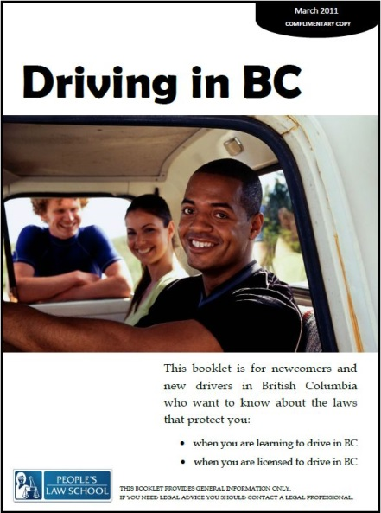

Lesson Plan: Safe Driving (CLB 7-8)
CLB Outcomes
CLB 8-III: Getting Things Done | Understand communication intended to influence or persuade (such as extended warnings, threats, suggestions, recommendations and proposed solutions) in situations related to personal decisions or to work-related issues in own field.
CLB 7-III: Getting Things Done | Give extended warnings, suggestions, recommendations or advice.
CLB 7-III: Getting Things Done | Get information from moderately complex business/ service texts containing assessments, evaluations and advice.

Content Outcomes
- Identify the rules and penalties associated with safe driving, including impaired driving, seat belts, child car seats, cell phones and pedestrians
- Identify where to get more information about safe driving

Resources
- People’s Law School (PLS) booklet, Driving in BC, p. 8-9
- PLS worksheets “Driving in BC: Safe Driving”
- Video, “Is it your turn to be a designated driver?” http://www.youtube.com/watch?v=wHoYR5HoxOU#at=20
- Video, “Counter attack: holiday ad,” http://www.youtube.com/watch?v=oKDq__F5xiU
- Computer Lab (optional)

External Resources and Referrals
- For more information on safe driving, visit www.icbc.com.
- Invite a driving school instructor to speak to the class about safe driving
- Visit an ICBC driver licensing centre near you; students can pick up a copy of ICBC’s Learn to Drive Smart booklet

Assessment Plan and Tools
- Self-assessment checklist
Sample Lesson Plans
Time | Sample Tasks | Expected Outcome | Resources
15’ | Warm up  - In pairs or small groups, students discuss their experience of driving  - In pairs or small groups, students discuss their knowledge of safe driving in BC  - Go over vocabulary, if needed  - Assess level of knowledge of/ interest insafe driving in BC | Generate interest  Activate prior knowledge | PLS Worksheet:  Get Ready!
15’ | Predict and Read  - Copy and cut strips  - Students put the strips in categories:  rules, penalties and recommendations  - Students rank cards according to severity and by predicting which infraction will garner which penalty  - Students confirm their predictions by readingDriving in BC, p. 8-9  - Go over any new vocabulary,  encourage students to apply word attack strategies first | Identify the rules and penalties associated with safe driving in BC  Identify other recommendations for safe driving | PLS Worksheet: Predict!  Driving in BC, p. 8-9.
10’ | Pronunciation: Word Stress  - Students break words into syllables and mark stress  - Drill pronunciation | Pronounce multi-syllabic words with correct word stress | PLS Worksheet:  Say it!
15’ | Discussion  - In small groups, students compare safe drivingin a cross-cultural context | Think critically  Relate information to their own lives | PLS Worksheet:  Talk about it!
20’ | Research  - Individually or in pairs, students search for more information about one safe driving topic  - Students take notes of key information  - Students share the information with their classmates | Get information from moderately complex business/ service texts containing assessments, evaluations and advice | PLS Worksheet:  Find out More!  Computer lab

Time | Sample Tasks | Expected Outcome | Resources
25’ | View ICBC safe driving videos  - Students view the two videos  - Students compare the videos on a variety of criteria by filling in the table  - In small groups, students compare their answers and discuss  - Facilitate a whole class discussion of the two videos, focusing on the language and techniques used to persuade and influence | Understand communication intended to influence or persuade (such as extended warnings, threats, suggestions, recommendations and proposed solutions) | PLS Worksheet:  View and Compare!  Video: “Is it your turn to be a designated driver?”  Video: “Counter attack: holiday ad”
30’ | Use persuasive devices  - In pairs or small groups, students prepare a public service announcement (PSA) on a safe driving using language and techniques to influence and persuade  - Students edit and practice their PSA  - Students present their PSA to the class | Get more information about getting a BC driver’s license | PLS Worksheet: Convince Us!
10’ | Self-Assessment  - Allow students to fill out self-assessment form independently | Self-assessment | PLS Worksheet:  What did I learn?

Get Ready!
Discuss your level of experience and familiarity with driving in your country of origin and in BC. Use these prompts.
  - Experience as a driver
  - Experience as a passenger
  - Experience as a pedestrian
  - Safe and unsafe areas in your community

Get Ready!
Look at the words below. What do you know about safe driving in BC?

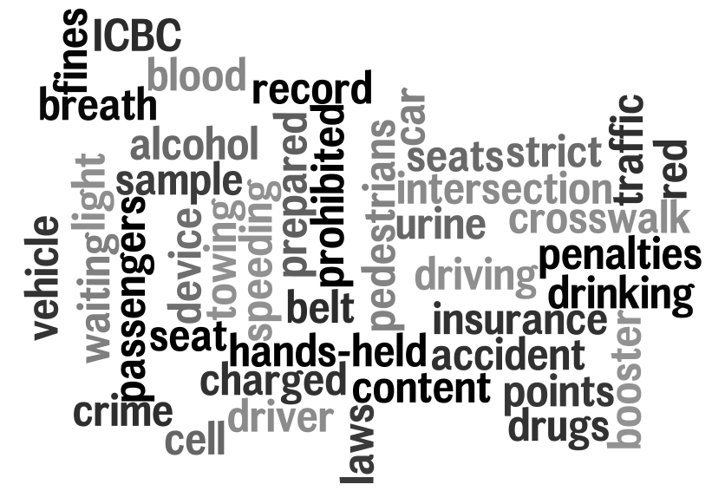

Predict!
Copy and cut these into strips. Get your students to categorize them into rules, penalties and recommendations, and then to rank them according to the severity of the infraction or penalty. NOTE: In the table below, the rules and penalties do not necessarily correspond.

RULES | PENALTIES | RECOMMENDATIONS
Wear a seat belt | Pay a fine | Keep children in the back seat
Obey speed limits | Get driver penalty points | Look both ways at intersections
Do not drive while impaired | Lose your license | Have a designated driver
Use a car seat for children under 9 kg | Pay to get your license back | Be prepared to stop at all intersections
Obey traffic lights | Pay more for car insurance | Drive with your headlights on
Do not use a hand-held electronic device | Be prohibited from driving for a year or more | Focus on driving, not on your phone
Stop for pedestrians at all intersections and crosswalks | Have your car towed | Take driving lessons from a reputable driving school.

Read!
Students can confirm their predictions by scanning for information on pg. 8-9.

Say it!
First, mark the syllables and word stress on the words below. Next, practice saying these words with the correct word stress. If you are not sure what these words mean, guess, ask a friend, look in a dictionary or ask your teacher.

intersections in’ ter sec tions
prohibited
insurance
reputable
pedestrians
electronic
device
impaired
penalty
penalize
designated

Talk about it!
- How does road safety in BC compare to road safety in your country of origin? Is there any difference in people’s attitude towards safety?
- Are the laws tougher here or there? Penalties? Enforcement?
- Does the government use the media to educate people about safe driving?
- In what ways can we change people’s behavior? What do you think is the most effective way to change behavior? (E.g. education, incentive, punishment) Why?

Find out More!
Use a computer at school or at home to research a safe driving topic of your choice. (Hint: remember the ICBC website is www.icbc.com). Share your information with your classmates.

- Speeding
- Distracted driving
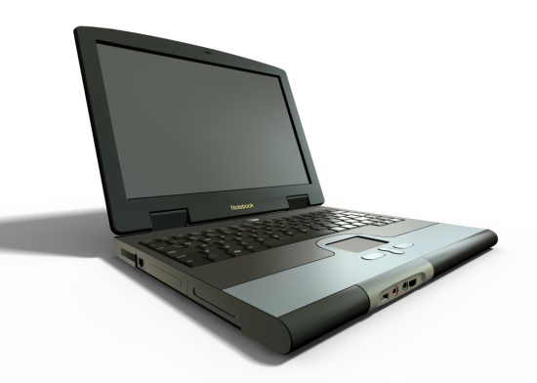
- Seat belts
- Child car seats and boosters
- Motorcycle riders
- Winter driving
- Being safe as a pedestrian
- Cyclists

View and Compare!
Over the years, ICBC has worked hard to educate BC drivers about safe driving. One method is the educational video, which usually appears as a television ad. Watch two of these ads at
- “Is it your turn to be a designated driver?” http://www.youtube.com/watch?v=wHoYR5HoxOU#at=20
- “Counter attack: holiday ad,” http://www.youtube.com/watch?v=oKDq__F5xiU

Compare the videos on the following criteria:
Criteria | Video 1: Designated Driver | Video 2: Counter Attack
Audience: Who is this message aimed at? Age? Lifestyle? Family status?
Techniques: Does this add use fear? facts? humour? shock value?
Focus: Does this ad focus on education, punishment, or incentive?
Effectiveness: Which ad do you think is more effective? Why?
Other: Do you have any other observations or comments about these videos?

Convince Us!
Imagine you are a consultant hired by ICBC to create a 2 minute public service announcement (PSA) to encourage drivers (or pedestrians, motorcyclists or cyclists) to be safe. Script out and perform your PSA for your classmates.
Before you write your script
- Consider your audience
- Consider your level of formality
- Consider how you will grab your audience’s attention
After you write your script
- Edit it and re-write (ask your peers or teacher for feedback)
- Practice, practice, practice
- Present your PSA to your class

Giving Warnings& Recommendations
Capturing your audience’s attention
- Use facts
- Use emotion
- Use humour
- Use shock value
- Use intonation, facial expressions and gestures
Helpful phrases
- Did you know _____?
- If you____, you will _____.
- The police can _______
- What if ______?
- Slow down/Watch out/Stop!
- We all have to do our part.
- Drivers must _____.
- When you ____, you should___.

What did you learn?
Fill this out on your own.
 | Yes, I can do this on my own. | I need to review this. | I can’t do this yet.
I can identify some of the rules and penalties associated with safe driving in BC.
I know where to get more information about safe driving.
I can get information from this kind of informational text.
I can give warnings, suggestions, recommendations or advice.
I can recognize communication intended to influence or persuade.

What else did you learn today? What other questions do you have about safe driving in BC?

Say it! ANSWER KEY

intersections in’ ter sec tions
prohibited pro hi’ bi ted
insurance in sur’ance
reputable re’puta ble
pedestrians pede’strian
electronic e lectron’ ic
device de vice’
impaired impaired’
penalty pe’ nal ty
penalize pe’ nalize
designated des’ ignated

