Workplace Bullying
and Harassment:
Lesson: What you need to Know

CLB 7-8 Instructional Package

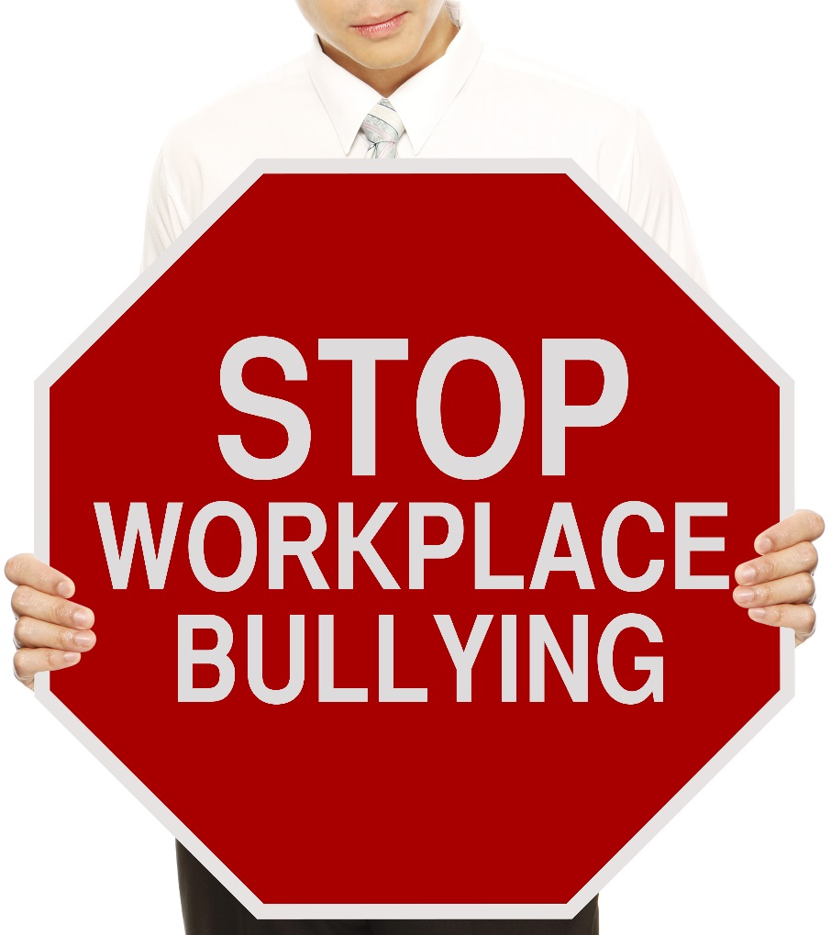

and Harassment
Lesson Plan: What you Need to Know (CLB 7-8)
CLB Outcomes
CLB 7-III: Getting Things Done | Give extended warnings, suggestions, recommendations or advice.
CLB 8-II: Comprehending Instructions | Understand extended, moderately complex, multistep instructions and instructional texts for established (set) procedures related to specialized tasks.
CLB 7-III: Getting Things Done | Write business or service correspondence for a range of routine and less routine purposes (such as passing on information, and making and responding to requests, recommendations and warnings).

Content Outcomes
- Identify the impacts of workplace bullying
- Describe roles and responsibilities in regards to workplace bullying/ harassment
- Identify procedures for reporting incidents and conducting investigations into workplace bullying/ harassment
- Be able to get more information about workplace bullying/harassment

Resources
- People’s Law School (PLS) booklet, Workplace Bullying and Harassment, sections on What employers need to know and What workers need to know
- PLS worksheets “Workplace Bullying & Harassment: What you Need to Know”
- Computer Lab (optional)

External Resources and Referrals
- For more information on this bullying and harassment, visit WorksafeBC at http://www.worksafebc.com/default.asp

Assessment Plan and Tools
- Self-assessment checklist

Lesson Plan: What you Need to Know (CLB 7-8)
Sample Lesson Plan
Time | Sample Tasks | Expected Outcome | Resources
15’ | Warm up  - In pairs or small groups, students talk about pictures  - Go over vocabulary and answers  - Assess level of knowledge of/interest in workplace bullying | Generate interest  Activate prior knowledge | PLS Worksheet:  Get Ready!
20’ | Predict and read  - Students generate lists of behaviours that are acceptable, bullying and criminal  - Students read the first few sections of the PLS Booklet, Workplace Bullying & Harassment, to check their predictions  - Students discuss cultural and gender differences in bullying | Identify behaviours that are considered acceptable, bullying and criminal | PLS Worksheet: Predict!  Workplace Bullying and Harassment
15’ | Vocabulary  - Students analyze the difference between similar words  - Students write and share sentences that illustrate the difference between the similar words  - Teach pronunciation as needed | Apply vocabulary building strategies | PLS Worksheet: Build your Vocabulary!
30’ | Read and summarize  - Read the rest of the booklet and summarize the key information in a series of graphic organizers  - Demonstrate an understanding of the procedures for preventing, reporting and investigating workplace bullying | Understand instructions and instructional texts.  Identify the impacts of workplace bullying; roles and responsibilities; procedures for reporting, etc | PLS Worksheet: Read and Summarize!
45’ | Case Studies  - In groups, students read and discuss 4 situations and determine if the behavior would be considered bullying  - Assign one case to each group for in-depth analysis and reporting on  - Students work together to write a report and recommend solutions for one of the case studies  - Teams present their case study at a mock all-staff meeting | Think critically  Demonstrate understanding of key concepts from the reading | PLS Worksheet: Apply it!
20’ | Role Play  - Take turns playing different roles and achieving different results of the conversation  - Present one role play to the class | Give extended warnings, suggestions, recommendations or advice. | PLS Worksheet: Speak Up!
30’ | Research  - Support and coach students on how to navigate the WorkSafe BC website (a demonstration might be necessary)  - Students work independently or in pairs to find the information  - Go over answers | Identify where to get more information about workplace bullying/harassment | PLS Worksheet:  Find out More!  Computer lab  http://www.worksafebc.com/
10’ | Self-Assessment  - Allow students to fill out self-assessment form independently | Self-assessment | PLS Worksheet: What did you learn?

Lesson Plan: What you Need to Know (CLB 7-8)
Get Ready!
Look at the pictures below.

  - What is happening (be specific)?
  - What are the impacts of this behavior in the workplace?
  - What do you already know about this topic?

Images from Shutterstock.com
Lesson Plan: What you Need to Know (CLB 7-8)
Predict!
You will read a booklet about workplace bullying and harassment. (Note: The expressions “bullying” and “harassment” are used to mean the same thing - WorkSafe BC defines both as "any inappropriate conduct or comment by a person towards a worker that the person knew or reasonably should have known would cause that worker to be humiliated or intimidated.")
). Work in small groups to generate a list of behaviours you believe are considered acceptable, bullying and criminal according to BC legal standards.

Acceptable Behaviours | Bullying Behaviours | Criminal Behaviours
joking around with co-workers | constantly making jokes about a person | stalking

Read and check!
Read the PLS booklet Workplace Bullying and Harassment to check your answers. Were there any surprises?

Lesson Plan: What you Need to Know (CLB 7-8)
Talk about it!
Discuss the definition and examples of bullying. Consider the following:
  - Do you agree with the definitions?
  - Are there cultural differences in what is defined as bullying or is it universal?
Support your answer with reasons and examples.
  - Are there gender differences in bullying? Why or why not?
Build your Vocabulary!
Talk about the words below. What are the similarities and differences? Use examples and definitions to support your points.

- humiliate vs. embarrass
- feedback vs. advice
- stalk vs. follow
- race vs. ethnicity
- discrimination vs. harassment
- productivity vs. performance
- policy vs. procedure
- intimidate vs. feel afraid
- offensive vs. rude
- gossip vs. slander

  - Is the difference in meaning? in degree? in impact? in collocation?
  - What does the internet have to say about the differences between these words? Your dictionary? A monolingual dictionary?

Now work with a partner to write two sentences that illustrates the difference between one of the pairs of words. Share your sentences with the rest of the class.

Example:
- a) I was humiliated when my boss called me an idiot in front of a group of my clients.
- b) I was embarrassed when I arrived late to class.
Lesson Plan: What you Need to Know (CLB 7-8)
Read and Summarize!
Graphic organizers are an excellent way of summarizing and presenting information.

Read the rest of the booklet, Workplace Bullying and Harassment, and summarize the information in your notebook using graphic organizers.

- The Impacts of Workplace Bullying and Harassment

Lesson Plan: What you Need to Know (CLB 7-8)

- Roles and Responsibilities in the Prevention of Workplace Bullying and Harassment

Employers |  |  |  | Employees
How are their roles & responsibilities similar?
How are their roles & responsibilities different?

Lesson Plan: What you Need to Know (CLB 7-8)

- Procedures for reporting incidents and conducting investigations

Lesson Plan: What you Need to Know (CLB 7-8)
Apply it!
Choose one of the following case studies to analyze with a group.

Case Study 1

Carol works for a large company as an accountant. Sometimes, when the receptionist is on her lunch break, Carol’s boss asks her to sit at the reception desk and answer phone calls. Carol has told her boss she doesn’t like doing this, but he keeps asking her to do it. Carol’s husband thinks she should confront her boss, but her co-worker, who knows the boss, thinks this is a bad idea.

Case Study 2

Two of Kevin’s co-workers have been telling other employees that he is an alcoholic. Although Kevin did get drunk at the Christmas party last year, Kevin knows he is not an alcoholic. Someone has even taken a photo of Kevin and photo shopped a glass of beer into his hand and posted it on Facebook. Kevin is worried that his boss might see the picture.

Case Study 3

Mike’s boss has just told him that he has made some mistakes in the cashing out process at the end of the day. She said that he needs to be more careful, and if he makes any more mistakes, he will have to stop working as a cashier and go back to working in the warehouse. Mike feels his boss always picks on him and won’t help him do his job properly.

Case Study 4

When Sarah’s boss gets angry, he yells at her and calls her stupid. He usually apologizes for yelling. Then, a few days later, the cycle repeats itself. This has been happening for a long time. Although Sarah is the most frequent target of her boss’ anger because she is his assistant, the boss has yelled at almost everyone in the firm at some point. Sarah is often afraid of her boss getting angry. She has become depressed and has started yelling at her kids at home.

Case Study Procedures
Your team has been hired as management consultants to address a situation of alleged workplace bullying. You will write a report to the President of the company. Follow the template below. You will then present your recommendations at an all-staff meeting.

Report to:
Submitted by:
Regarding:
Date:
Background (Describe the situation)
- Identify the key players.
- Identify the actions/ behaviours.
- Identify the impact of the behavior.

Evaluation (Analyze the situation)
- Determine if the details are fact or opinion.
- Determine if the behavior is acceptable or bullying.
- Determine if the impacts are mild or severe.

Recommendations (Suggest how to solve the problem)
- Determine if any action is necessary.
- If not, explain why the behavior is acceptable and of mild impact.
- If so, suggest a specific course of action to address the situation.
- Suggest strategies for preventing this situation from re-occurring.

Lesson Plan: What you Need to Know (CLB 7-8)
Speak up!
If someone is bullying you, the first thing to do is to tell them it bothers you. Use the case study situations above and role play trying to address the problem directly. Practice and perform your skit to the rest of the class.

Case Study 1: Carol the Accountant

  - Carol tells her boss she does not want to fill in for the receptionist. She says she is too busy with month end. Besides she hasn’t been trained on the phone system.
  - Carol’s boss insists that Carol has to pitch in because they are short staffed. He really respects her as a professional, but he has a business to run and can’t keep wasting time talking about something so insignificant.

Case Study 2: Kevin the non-alcoholic

  - Kevin confronts the person who posted the compromising picture on Facebook and asks her to take it down. He explains how this could impact his career and how it has impacted his level of stress. He warns them that he will have to file a harassment report if they don’t stop.
  - Kevin’s co-worker defends herself by saying it was just a joke. She feels Kevin is taking the situation too seriously.

Case Study 3: Mike the careless cashier

  - Mike’s boss tells him that he has made some mistakes in the cashing out. He needs to be more careful, and if he makes any more mistakes, he will have to stop working as a cashier and go back to working in the warehouse. You have 50 employees to supervise, and Mike has been given 3 chances to improve.
  - Mike tells his boss he feels that she always picks on him and won’t help him do his job properly. He complains that working in the warehouse is too cold.

Lesson Plan: What you Need to Know (CLB 7-8)
Find out More!
Use a computer at school or at home to find out the following information from the WorkSafe BC website.
- What is the phone number of the “prevention line?” What is its purpose?

- Open the document called, “Frequently Asked Questions.” Copy three pieces of information that are interesting to you.

- Outline the steps in the complaints submission process:

Lesson Plan: What you Need to Know (CLB 7-8)
What did you learn?
Fill this out on your own.
 | Yes, I can do this on my own. | I need to review this. | I can’t do this yet.
I can describe the difference between bullying and non-bullying behaviours.
I can describe how to prevent and report workplace bullying.
I can find information about workplace bullying and harassment.
I can make suggestions and recommend solutions to a problem.
I can read and understand procedures.

What else did you learn today? What other questions do you have about workplace bullying and harassment?

