Family Law
Lesson: Family Violence

CLB 5-6 Instructional Package

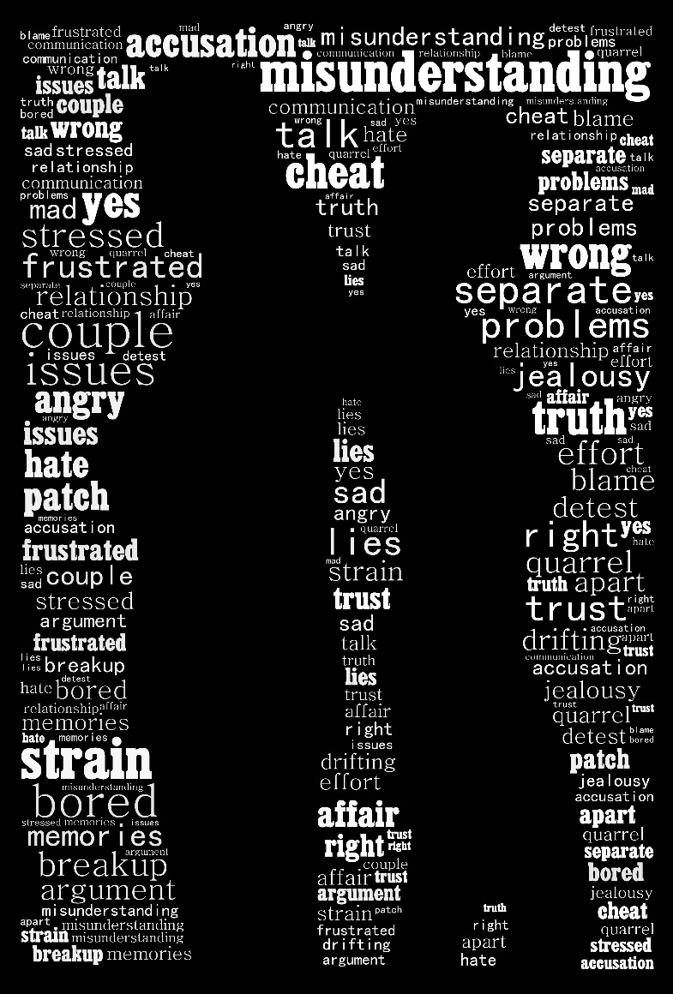

PLACEHOLDER IMAGE
Lesson Plan: Family Violence (CLB 5-6)

CLB Outcomes
CLB 5-III: Getting Things Done | Give and respond to informal requests, permission, suggestions and advice.
CLB 6-IV: Comprehending Information | Understand moderately complex descriptive or narrative texts on familiar topics.
CLB5-II: Reproducing Information | Reduce a page of information to a list of important details.

Content Outcomes
- Identify what to do in situations of family violence
- Identify services available for victims of violence
- Be able to get more information or find services for family violence

Resources
      - People’s Law School (PLS) booklet, Family Violence & Abuse, section on Keeping Your Family Safe
- PLS worksheets “Family Law: Family Violence”
- Computer Lab (optional)

External Resources and Referrals
- For more information on services for victims of family violence, visit Victim Services at http://www.pssg.gov.bc.ca/victimservices/index.htm.

Assessment Plan and Tools
- Self-assessment checklist

Lesson Plan: Family Violence (CLB 5-6)
To the Instructor:
The topic of family violence is a difficult one to address in a classroom; however, it is a very important one. There are a few things to keep in mind as you explore this topic:
- Alert your coordinator to your intention to cover this topic.
- Review your school policy about referrals.
- Tell the students ahead of time that you will be covering this topic.
- Try to keep the discussion factual, not personal.
- If a student discloses that they are or have been the victim of violence, talk to your coordinator and make a referral.
- Remember, you are not a counsellor.
Sample Lesson Plan
Time | Tasks | Expected Outcome | Resources
15’ | Warm up  - Avoid the use of visual images for this topic  - Set discussion ground rules  - Review the language of avoidance and deflection | Set ground rules  Review the language of avoidance and deflection | PLS Worksheet:  Get Ready!
20’ | Predict and read  - Students predict one thing they expect to read and write one question for each section of the booklet  - Students scan the PLS Booklet, Family Law: Family Violence, to check their predictions and answer their questions | Develop the reading strategies of prediction and questioning  Scan for details | PLS Worksheet:  Predict!  Family Law: Family Violence
15’ | Vocabulary  - Students match words, parts of speech and synonyms  - Students locate and copy sentences illustrating the target words  - Teach pronunciation as needed | Apply vocabulary building strategies | PLS Worksheet:  Build your Vocabulary!
40’ | Read and summarize  - Students read the PLS booklet section 2.1 to 2.3 and summarize the key details | Summarize information  Identify what to do in a situation of family violence and where to get help | PLS Worksheet:  Read and Summarize!
40’ | Giving Advice  - Students put the conversation in order, either by writing a number in the adjacent box, or the teacher can cut the dialogue into strips  - Students analyze the conversation for vocabulary , register and functional language  - Students practice giving advice using phrases identified in the dialogue | Apply language analysis strategies  Give advice | PLS Worksheet:  Give Advice!
30’ | Research  - Students work independently or in pairs to find the information  - Go over answers | Identify where to get more information about family violence | PLS Worksheet:  Find out More!  Computer lab
10’ | Self-Assessment  - Allow students to fill out self-assessment form independently | Self-assessment | PLS Worksheet:  What did you learn?

Lesson Plan: Family Violence (CLB 5-6)
Get Ready!
You are going to read about family violence. The reading and discussion will focus on keeping safe and about finding services. This topic can be very difficult to talk about.

Before you start, work with your classmates and teacher to set some ground rules. Ground rules list expected behaviours for classroom discussions. Here are some examples to get you started. Can you add to the list?

Sample Ground Rules
- Have a clear purpose for the discussion.
- Listen attentively.
- Focus on the technical aspects of the topic.
- Avoid sharing personal stories.
- ____________________________________________________________________
- ____________________________________________________________________
- ____________________________________________________________________
This topic may make you feel anxious. It is okay to take a break or change the topic.
Review the language of avoidance.
I’d rather not talk about that.
Can we change the subject?
That makes me uncomfortable.
Excuse me. I think I need a break.

Lesson Plan: Family Violence (CLB 5-6)
Predict!
You are going to read part of a booklet called Family Law: Family Violence. For each section below, list one thing that you expect you will read and one question you have.

 | Something I expect to read | A question I have
Keeping your family safe
Find out about services

Read and Check!

Read the People’s Law School (PLS) booklet, Family Violence & Abuse to confirm your predictions, and see if your questions were answered.

Build your Vocabulary!
Cut up the following chart into cards, and match.
Word | Part of Speech | Synonyms
evidence | noun | sign, clue, proof
harm | verb/noun | hurt, damage, loss
threaten | verb | scare, blackmail, frighten
transition house | noun | safe house, hiding place
peace bond | compound noun | protective order, legal notice to stay away
sponsor | noun – person | backer, supporter
victim | noun - person | one who is hurt

For each word, find an example sentence in the PLS booklet, and write it next to the word.
- evidence_____________________________________________________________
- harm________________________________________________________________
- threaten______________________________________________________________
- transition house________________________________________________________
- peace bond____________________________________________________________
- sponsor_______________________________________________________________
- victim_________________________________________________________________
Lesson Plan: Family Violence (CLB 5-6)
Read and Summarize!
Graphic organizers are useful for summarizing and presenting information. Read the PLS booklet, Family Violence & Abuse in more detail this time.

- Keeping My Family Safe - Put the following pieces of information in the correct category.

call the police or victim link for help
tell the police about what happened
may help you get a peace bond
may decide to arrest the abuser
may take you and your children to a transition house
can give you help in your first language
call 1-800-563-0808, no charge, 24 hours a day
may give you a victim services worker to help you

Lesson Plan: Family Violence (CLB 5-6)
- Find out about services – Add 3 details to each section on this chart.

Give Advice!
Put the conversation in order. Write the numbers 1-15 in the boxes.
Mei | Yeah, that’s the one. So, you know how I told you that I can hear her and her husband arguing? Well, I think it’s actually worse than arguing. Last night I heard him screaming at her and then what sounded like a scuffle. I am pretty sure he pushed her into a wall.
Sukh | OK, so I think you should call Victim Link. Here I’m going to google the phone number for you right now. [finds it on her smart phone] Here it is. It’s 1-800-563-0808. I’ll text it to you. Anyway, I think the best thing to do is to call them first. I am sure they will know what you can do to help.
Suki | Not bad, Mei. How about you?
Mei | Yeah, things are pretty good right now, but I am really worried about my next door neighbour.
Suki | Why? What’s up? You mean Marion, right? The woman with the new baby?
Mei | Hey Suki. How’s it going?
Suki | Oh my god, that’s awful. What did you do?
Suki | OK, take care, Mei, and let me know how it turns out.
Suki | Well, you gotta do something to help her. She has no family here, right?
Mei | You’re right, but I don’t have a clue where to start.
Mei | Will do. Bye, thanks again!
Mei | Nothing. I was so shocked; I didn’t know what to do. Then this morning, I saw her taking her son to school and she wouldn’t make eye contact with me. I know something’s wrong.
Suki | If that happens, you have to call 911. He could really hurt her or the kids, you know.
Mei | Yes, you’re right. I gotta run for my bus now, but I can’t thank you enough for the advice! I feel a lot better knowing that I can get her some help.
Mei | Thank you so much! I didn’t know about that. I must admit that I’m a bit freaked out. What if I hear him going after her again tonight?
Lesson Plan: Family Violence (CLB 5-6)
Give Advice!
Think about the conversation.
- In informal spoken English, we often use reduced forms like “gotta” that we don’t use in writing, except on social media or in texting. Can you find any other examples in the dialogue of expressions or forms that are acceptable in spoken English, but would not be acceptable in formal written English?
______________________________________________________________________________________________________________________________________________________
2. Find a word or phrase that has the same meaning as
don’t know ________________________________
upset/scared ________________________________
a short, confused fight ________________________________
attacking ________________________________
must ________________________________
- Mei doesn’t directly ask for advice, but she does imply that she needs help to support her neighbour. What does she say that causes Suki to offer advice?
____________________________________________________________________________________________________________________________________________________
- How does Suki give Mei advice? What does she say? ____________________________________________________________________________________________________________________________________________________
- Do you think Mei will take Suki’s advice? How do you know? ____________________________________________________________________________________________________________________________________________________
Lesson Plan: Family Violence (CLB 5-6)
Give Advice!

Giving Advice

Asking for help indirectly
I am really worried about _____.
You know how I told you that __, well, I think ______.
I don’t have a clue how to ____.
What if ______?

Offering advice
Why? What’s up?
You’ve gottado something to ____.
OK. I think you should _______.
Here, I’m going to google the _____.
I’ll text it to you.
Anyway, I think the best thing to do is ______________.
If that happens, you have to ______.
Let me know how it turns out.

Accepting advice
You’re right, but I ______.
I can’t thank you enough.
I feel better knowing that _____.

Practice giving advice using some of the phrases from the dialogue.

- Your classmate has a really bad toothache and needs to find a dentist quickly. She is worried about the cost.

- Your co-worker’s landlord keeps entering his apartment while he’s at work. He’s asked the landlord to give him some warning if he needs to go into the apartment.

- Your neighbour, who is from the same country of origin as you are, doesn’t speak any English and is having a hard time settling into life in BC.

- Your cousin just got a job, but is working under the table for cash. You are worried that if he gets hurt on the job that he won’t be eligible for worker’s compensation.

- Make up a situation of your own.

Lesson Plan: Family Violence (CLB 5-6)
Find out More!
Use a computer at school or at home to find out more about Victim Link BC at http://www.victimlinkbc.ca/.
- What is VictimLink BC? How can you contact them?
____________________________________________________________________________________________________________________________________________________
- Is this only for victims of family violence? What other sorts of victims do they provide services for?
______________________________________________________________________________________________________________________________________________________
- In how many languages can you receive services?
______________________________________________________________________________________________________________________________________________________
- Peter was the victim of assault and needs to replace his glasses, which were broken in the attack. He doesn’t have enough money for this. What should he do? ______________________________________________________________________________________________________________________________________________________
- List one more pieces of information from the website that you didn’t know before. ______________________________________________________________________________________________________________________________________________________

Lesson Plan: Family Violence (CLB 5-6)
What did you learn?
Fill this out on your own.
 | Yes, I can do this on my own. | I need to review this. | I can’t do this yet.
I can describe what to do in situations of family violence.
I can identify some services available for victims of family violence.
I can find more information about family violence.
I can use graphic organizers to help me take notes from a text.
I can give and respond to informal advice and suggestions.

What else did you learn today? What other questions do you have about family violence?
________________________________________________________________________________________________________________________________________________________________________________________________________________________________________________________________________________________________________________________
Lesson Plan: Family Violence (CLB 5-6)

Read and Summarize!
ANSWER KEY

- Keeping My Family Safe - Put the following pieces of information in the correct category.

Lesson Plan: Family Violence (CLB 5-6)
Give Advice!
ANSWER KEY

Mei | Hey Suki. How’s it going?
Suki | Not bad, Mei. How about you?
Mei | Yeah, things are pretty good right now, but I am really worried about my next door neighbour.
Suki | Why? What’s up? You mean Marion, right? The woman with the new baby?
Mei | Yeah, that’s the one. So, you know how I told you that I can hear her and her husband arguing? Well, I think it’s actually worse than arguing. Last night I heard him screaming at her and then what sounded like a scuffle. I am pretty sure he pushed her into a wall.
Suki | Oh my god, that’s awful. What did you do?
Mei | Nothing. I was so shocked; I didn’t know what to do. Then this morning, I saw her taking her son to school and she wouldn’t make eye contact with me. I know something’s wrong.
Suki | Well, you gotta do something to help her. She has no family here, right?
Mei | You’re right, but I don’t have a clue where to start.
Suki | OK, so I think you should call Victim Link. Here I’m going to google the phone number for you right now. [finds it on her smart phone] Here it is. It’s 1-800-563-0808. I’ll text it to you. Anyway, I think the best thing to do is to call them first. I am sure they will know what you can do to help.
Mei | Thank you so much! I didn’t know about that. I must admit that I’m a bit freaked out. What if I hear him going after her again tonight?
Suki | If that happens, you have to call 911. He could really hurt her or the kids, you know.
Mei | Yes, you’re right. I gotta run for my bus now, but I can’t thank you enough for the advice! I feel a lot better knowing that I can get her some help.
Suki | OK, take care, Mei, and let me know how it turns out.
Me | Will do. Bye, thanks again!

Lesson Plan: Family Violence (CLB 5-6)
Give Advice!
Think about the conversation. ANSWER KEY
- In informal spoken English, we often use reduced forms like “gotta” that we don’t use in writing, except on social media or in texting. Can you find any other examples in the dialogue of expressions or forms that are acceptable in spoken English, but would not be acceptable in formal written English?
How’s it going?; pretty good; What’s up?; You mean…, right?; Yeah; you know how I…; pretty sure; oh my god; you gotta; freaked out; you know (as a tag question); will do.
- Find a word or phrase that has the same meaning as
don’t know don’t have a clue
upset/scared freaked out
a short, confused fight a scuffle
attacking going after
must gotta; have to
- Mei doesn’t directly ask for advice, but she does imply that she needs help to support her neighbour. What does she say that causes Suki to offer advice?
I’m really worried about …; I didn’t know what to do; I don’t have a clue where to start.

- How does Suki give Mei advice? What does she say?
You gotta do something to help her; I think you should call…; I think the best thing to do is to …; If that happens, you have to …
- Do you think Mei will take Suki’s advice? How do you know?
Yes, because she says, “Thank you so much. I didn’t know about that.” and “I feel better knowing…”

