Paying Taxes
Lesson: Kinds of Taxes

CLB 5-6 Instructional Package

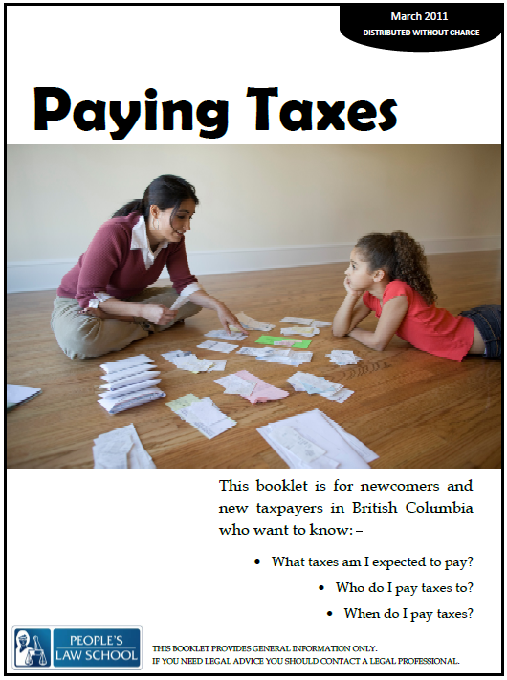

Lesson Plan: Kinds of Taxes (CLB 5-6)
CLB Outcomes
CLB 6-IV: Comprehending Information | Understand group interactions and discussions on familiar topics.
CLB 5-III:Getting Things Done | Give and respond to informal requests, permission, suggestions and advice.
CLB 6-IV:Comprehending Information | Understand simple to moderately complex descriptive or narrative texts on familiar topics.

Content Outcomes
- Identify the different kinds of taxes in Canada
- Identify where to get more information about funds that are tax free

Resources
- People’s Law School (PLS) booklet, Paying Taxes, p. 3 – 6.
Note to instructor: People’s Law School booklet Paying Taxes was accurate at date of publishing. Please note that since publishing the HST has been withdrawn and an increase in value of goods a traveller can bring into Canada from the US after 48 hours has changed.
- PLS worksheets “Paying Taxes: Kinds of Taxes”.
- Computer Lab (optional)

External Resources and Referrals
For more information on income tax, visit the CRA website at http://www.cra-arc.gc.ca/.
Invite an accountant to come to your class to talk about taxes.

Assessment Plan and Tools
- Self-assessment checklist

Sample Lesson Plans
Note to instructor: People’s Law School booklet Paying Taxes was accurate at date of publishing. Please note that since publishing the HST has been withdrawn and an increase in value of goods a traveller can bring into Canada from the US after 48 hours has changed. Please adjust your lesson to provide accurate information.

Time | Sample Tasks | Expected Outcome | Resources
15’ | Warm up  - In pairs or small groups, students discuss the questions  - Go over vocabulary, if needed  - Assess level of knowledge of/interest in kinds of courts | Generate interest  Activate prior knowledge | PLS Worksheet:  Get Ready!
20’ | Predict and read  - Students predict by checking off the services that they think are paid for by taxes  - Students check their predictions in the PLS booklet  - In pairs, students discuss their opinions about taxes | Predict content through a check list  Skim and scan for information | PLS Worksheet:  Predict!  Paying Taxes,  p. 3-6.
20’ | Read and take notes  - Students skim the PLS booklet to take notes in the form of a mind map  - Students work in pairs to share their information and add to their notes | Read and taken notes  Use a graphic organizer to take notes  Skim and scan for information in the text | PLS Worksheet:  Create a Mind Map!  Paying Taxes,  p. 3-6.
25’ | Comprehension check  - In small groups, students play a game to check comprehension of materials  - Cut up one set of tax type card and statement cards for each group  - Explain the rules of the game:  - Place all of the statement cards face down in a pile on the table.  - Place the tax type cards spread out face up on the table.  - Take turns turning over a statement card and reading it aloud.  - Race to slam the tax type card that matches the statement.  - The first person to slam the correct tax type keeps the card.  - The person with the most cards at the end wins. | Assess level of comprehension of reading materials | PLS Worksheet:  Tax Slam!
20’ | Advice structures  - Students identify the differences in meaning between various ways of giving advice and suggestions  - Students categorize phrases  - Students complete sentences with appropriate information from the PLS booklet | Recognize the levels of strength and directness for giving advice and suggestions  Categorize phrases according to meaning | PLS Worksheet:  Give Advice!  Paying Taxes,  p. 3-6.
30’ | Group board game  - Students work in groups to play the conversation advice board game  - Give each group a coin and have them read through the rules on the worksheet:  - Flip a coin to find out how far to move: Heads = move 2 spaces/Tails = move 1 space  - As you land on a square, role play a conversation with someone in your group. Your partner will start the conversation using the phrase in the square. You must give appropriate advice or suggestions.  - If your group agrees and thinks the advice is accurate, you get a point.  - If you land on a question mark, you can ask anyone in your group a question related to taxes. Whoever answers appropriately gets a point. | Give advice and suggestions | PLS Worksheet:  Play the Game!
20’ | Find out more  - Students find out more about tax savings through researching two different kinds of tax free savings options  - Visit: http://www.tfsa.gc.ca/ or www.canlearn.ca/eng/savings/index.shtml | Computer Lab | PLS Worksheet:  Find out More!
10’ | Self-Assessment  - Allow students to fill out self-assessment form independently | Self-assessment | PLS Worksheet: What did you learn?

For more information
http://travel.gc.ca/returning/customs/bringing-to-canada/mini-guide
Get Ready!
Look at the pictures. What do you know about taxes in Canada? Discuss the different kinds of taxes in your countries? What is similar or different about taxes in Canada and your country?
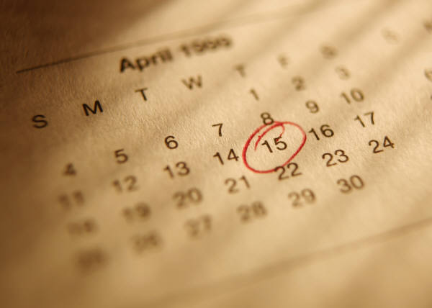
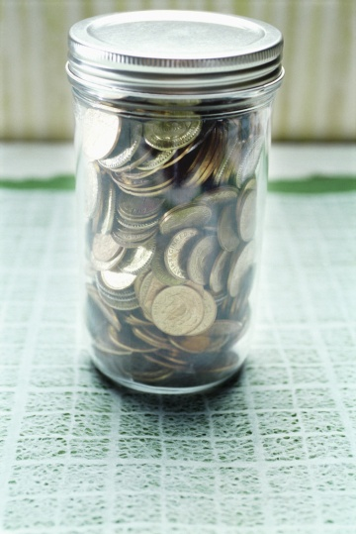
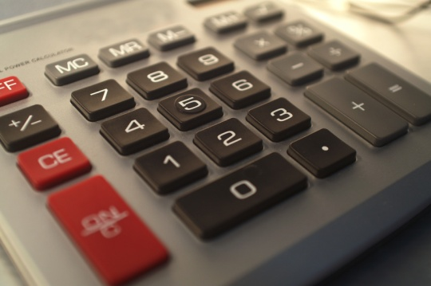
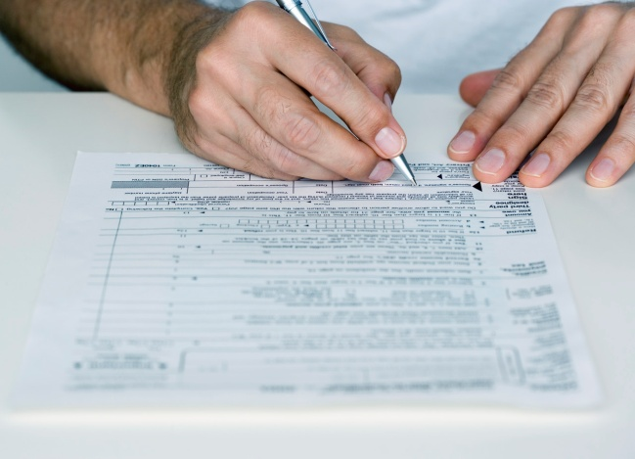

Predict!
Look at the list below. Which services are paid for through taxes? Check off all of the ones you think that taxes help to pay for. Check the People’s Law School booklet Paying Taxes to confirm your guesses.

- roads  - schools  - health care  - dental care  - natural path doctors  - parks  - bridges  - social services  - homeless shelters | - community centres  - police  - driver’s licenses  - daycares  - swimming pools  - universities  - massage therapy  - eye care  - vitamins

Discuss!
Discuss your opinions about taxes with a partner.
- From the list above, which services do you think should be paid for by taxes? Why do you think so?

- Which services should not be paid for by taxes? Why do you think this? Who should pay for them?

Create a Mind Map!
Skim and scan the People’s Law School booklet Paying Taxes to find information and facts about taxes. Organize your notes in the form of a mind map. Share your mind map with a partner and add further notes if your partner has ideas that you did not record.
TAXES
Kinds of
taxes
Income tax
Tax Slam!
Work in groups of three to play the Tax Slam game. Follow the instructions:
- Place all of the statement cards face down in a pile on the table.
- Place the tax type cards spread out face up on the table.
- Take turns turning over a statement card and reading it aloud.
- Race to slam the tax type card that matches the statement.
- The first person to slam the correct tax type keeps the card.
- The person with the most cards at the end wins.

Tax Type Cards:
Income Tax | Consumer Tax | Duty
Sales Tax | Property Tax

Statement Cards:
the biggest tax you pay | You don’t pay this tax for rent, groceries or public transportation.
You pay on most things you buy. | You pay this if you own a house, condominium, a building, or land.
You have to fill out a tax return for this type of tax. | You don’t have to pay this kind of tax on your own things if you move to Canada.
You pay this kind of tax on things you buy in another country and bring to Canada. | a combination of federal and provincial tax
carbon tax is one example | 12%
included in the price you pay for these specific items | You have to report this tax to the CRA every year.
If you are out of Canada for 7 days or more, you can bring back goods worth $800.00 without paying this tax. | You pay this on tobacco, short-term accommodations, and motor fuels.
You pay less of this kind of tax if you are a senior. | Your city or town government sends a letter every year to tell you how much you owe.

Give Advice!
In English, there are different ways to give advice. Some words and expressions are stronger and direct, more like commands, and others are suggestions that imply that there is a choice or option.
What is the difference in meaning between these two statements? Under which category would you place the statements?
You must be at the meeting by 3:00pm.
You should be at the meeting by 3:00pm.
It would be a good idea to… | You have to… | You should…
You must… | Why don’t you… | You need to…
You might want to… | What about…? | You can…

Categorize the following statements according to the meanings below.

statements that don’t imply an option or choice | statements that suggest something but imply that there is a choice or option

Look through the People’s Law School booklet Paying Taxes, p. 3 - 6 and complete the sentences below.
- You must _________________________________________________________________________.
- You have to _______________________________________________________________________.
- It would be a good idea to ___________________________________________________________.
- You should _______________________________________________________________________.
- You can __________________________________________________________________________.
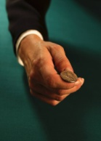
Play the Game!
Work in groups to complete the board game. The aim is to give appropriate advice or suggestions. Follow the instructions:
- Flip a coin to find out how far to move
Heads = move 2 spaces/Tails = move 1 space
- As you land on a square, role play a conversation with someone in your group. Your partner will start the conversation using the phrase in the square. You must give appropriate advice or suggestions.
- If your group agrees and thinks the advice is accurate, you get a point.
- If you land on a question mark, you can ask anyone in your group a question related to taxes. Whoever answers appropriately gets a point.

START | I want to sell things out of my house for cash.
 |  | I want to start my own business.
I need help to fill out a tax return. | I want to learn about income taxes. | I am moving to Canada and I want to bring my things with me.
I have never filed income tax in Canada before.
 | I want to go shopping the United States next weekend. | I am going to buy my first home.
 |  | I make money in Canada and overseas.
FINISH |  | I want to clean out my house. I have boxes of receipts and tax files from previous years.

Find out More!
Find out about some areas where you can save money on paying taxes. Visit the websites and answer the questions.
Tax Free Savings Account (TFSA) http://www.tfsa.gc.ca/

- What is a TFSA?

- What are the benefits of a TFSA?

- How much can you put into a TFSA every year?

- What else did you learn about TFSAs?

Registered Education Savings Plan (RESP) http://www.canlearn.ca/eng/savings/index.shtml

- What is a RESP?

- What are the benefits of an RESP?

- How much does the Canadian Education Savings Grant add to my RESP?

- What else did you learn about RESPs?
What did you learn?
Fill this out on your own.
 | Yes, I can do this on my own. | I need to review this. | I can’t do this yet.
I can list and provide information about the different types of taxes in Canada.
I can organize notes in the form a mind map.
I can give advice and suggestions.
I can get information from websites about taxes.

What else did you learn today? What other questions do you have about taxes in Canada?
________________________________________________________________________________________________________________________________________________________________________________________________________________________________________________________________________________________________________________________

Predict!
ANSWER KEY

Income Tax | Property Tax | Duty
the biggest tax you pay | your city or town government sends a letter every year to tell you how much you owe | you pay this kind of tax on things you buy in another country and bring to Canada
you have to report this tax to the CRA every year | you pay this if you own a house, condominium, a building, or land | if you are out of Canada for 7 days or more, you can bring back goods worth $8000.00 without paying this tax
you have to fill out an tax return for this type of tax | you pay less of this kind of tax if you are a senior | you don’t have to pay this kind of tax on your own things if you move to Canada
Consumer Tax | Sales Tax
you pay this on tobacco, short-term accommodations, and motor fuels | provincial tax
carbon tax is one example | rate depends on what is purchased e.g. goods is 7%, alcohol 10%, accommodation 8%,
included in the price you pay for these specific items | You pay on most new and used goods in B.C.
 | You don’t pay this tax for rent or public transportation

- roads  - schools  - health care  - dental care  - natural path doctors  - parks  - bridges  - social services  - homeless shelters | - community centres  - police  - driver’s licenses  - daycares  - swimming pools  - universities (receive partial funding; students contribute through tuition fees)  - massage therapy  - eye care  - vitamins
Tax Slam!
ANSWER KEY

Income Tax | Consumer Tax | Duty | Sales Tax | Property Tax
the biggest tax you pay  You have to fill out a tax return for this type of tax.  You have to report this tax to the CRA every year. | carbon tax is one example  You pay this on tobacco, short-term accommodations, and motor fuels. | You pay this kind of tax on things you buy in another country and bring to Canada.  You don’t have to pay this kind of tax on your own things if you move to Canada.  If you are out of Canada for 7 days or more, you can bring back goods worth $800.00 without paying this tax. | You pay on most things you buy.  a combination of federal and provincial tax  12%  included in the price you pay for these specific items | You pay this if you own a house, condominium, a building, or land.  You pay less of this kind of tax if you are a senior.  Your city or town government sends a letter every year to tell you how much you owe.

Images taken from http://office.microsoft.com/en-us/?CTT=97.

