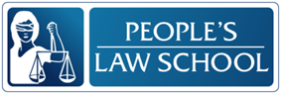

Driving in BC: Safe Driving

Listening Package

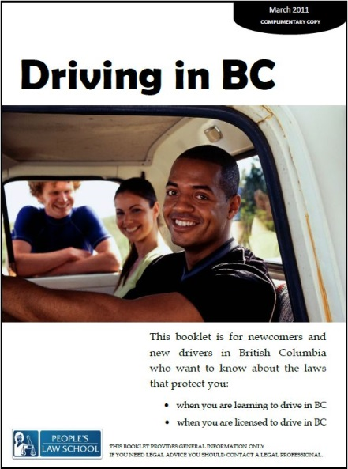

Listening Package: Driving in BC: Safe Driving
Lesson Objectives
- Identify the rules and penalties associated with safe driving, including impaired driving, seat belts, child car seats, cell phones and pedestrians
- Identify where to get more information about safe driving

Instructions for the Teacher
These listening tasks are based on the video on the Driving in BC Lesson Module page at http://wiki.clicklaw.bc.ca/index.php/Driving_in_BC_Lesson_Module

The following listening tasks have been modelled on the CLB 7-10 Exit Assessment Tasks that CLB 7/8 students take to progress or exit their programs. You may choose to use the tasks in a variety of ways:

- As a practice test
  - do not allow dictionaries or other supports
  - give each student a copy of the listening task
  - read the instructions
  - play the video twice through without stopping, pausing for 30 seconds between viewing
  - gather the tests and score them
- As listening skills development
  - generate interest and activate prior knowledge
  - set a gist task (Who? Relationship? Mood?)
  - watch, confer with small groups
  - watch, stop, predict, confirm
  - give listening tasks (below)
  - watch, confer with small groups
  - discuss content of videos
  - role play a related workplace situation
- As self-study
  - assign as in-class, online or at home work

Video Script
Mark: I passed my driver’s test dad.
Jeff: Good job son.
Mark: We should go for a drive, where should we go? We could go out to the Valley or go up to Whistler, We could go…………. (Jeff starts daydreaming)
Mark: (Mark gets into a car and does not put on his seat belt, he then proceeds to speed off and throws a beer can out the window, Mark speeds through a school zone and then speeds through a red light while talking on his cell phone, Speeding even faster and yelling Mark crashes the car) (Jeff drops his coffee cup)
Mark: Dad!?
Jeff: Oops. We should sit down and talk a bit.
Mark: Come on Dad can’t we talk later? I want to go drive.
Jeff: A little later. Have a seat.
Mark: Fine.
Jeff: (picking up the pieces of the coffee cup) Having a license is a big responsibility, your vehicle is basically a 5,000-pound weapon that you are in care and control of, and it must be treated with respect. Understand?
Mark: yes.
Jeff: The rules of the road are for your own safety and the safety of others. It’s important that they are respected, not just for safety but tickets and points on your license can cause you to lose it.
Mark: I promise I’ll be careful Dad
Jeff: Okay, let’s go (they both leave)

Listening Tasks
TASK A
Safe Driving
You will watch a video of a father and a son talking about driving. You will watch the video twice. As you watch, answer the questions. You have 30 seconds to read the questions before you listen.
Instructions: Circle the correct answers. Score: /7

Questions
- What is the son’s good news?
- He bought a new vehicle.
- He passed his citizenship test.
- He is now qualified to drive.

- Where are they going?
- To the driver’s licensing office.
- To Whistler.
- They have not decided yet.

- According to his father, having a license is _______________________.
- having respect from others.
- a big responsibility.
- controlling the lives of others.

- What does his father mean when he compares his vehicle to a “weapon”?
- Vehicles have the potential to do a lot of damage.
- His vehicle is very big and heavy.
- His vehicle is the same type as one used in war.
- Why does his father want to talk to him?
- He wants to tell him to keep driving as he does now.
- He wants to congratulate him on passing his driver’s test.
- He wants to talk about the responsibilities that come with driving.

- The rules of the road are for _______________.
- the safety of drivers.
- the safety of others.
- both A and B.

- Not respecting the rules of the road can cause a driver to _______________.
- lose points on their driver’s license.
- get a new license.
- gain respect from others.

Listening Tasks: Answer Key
TASK A
Instructions: Circle the correct answers. Score:

Questions
- What is the son’s good news?
- He bought a new vehicle.
- He passed his citizenship test.
- He is now qualified to drive.

- Where are they going?
- To the driver’s licensing office.
- To Whistler.
- They have not decided yet.

- According to his father, having a license is _______________________.
- having respect from others.
- a big responsibility.
- controlling the lives of others.

- What does his father mean when he compares his vehicle to a “weapon”?
- Vehicles have the potential to do a lot of damage.
- His vehicle is very big and heavy.
- His vehicle is the same type as one used in war.

- Why does his father want to talk to him?
- He wants to tell him to keep driving as he does now.
- He wants to congratulate him on passing his driver’s test.
- He wants to talk about the responsibilities that come with driving.

- The rules of the road are for _______________.
- the safety of drivers.
- the safety of others.
- both A and B.

- Not respecting the rules of the road can cause a driver to _______________.
- lose points on their driver’s license.
- get a new license.
- gain respect from others.

